Table of Contents

S1: Percentage (%) of missing covariates 1

S2: Intermittent missingness 2

S3: Simulation setting 6

S4: Bias and RMSE graphs for rest covariates 10

S4.1: MCAR graphs for rest covariates 10

S4.2: MNAR graphs for rest covariates 14

S4.3: RMSE graphs for rest covariates 18

S5: RMSE table 22

S6: Rcode 28

S6.1: Generating data in wave 1 29

S6.2: Generating smoking in waves 2 and 3 31

S6.3: Generating data in waves 2 and 3 32

S6.4: Generating MCAR & MNAR mechanisms 34

S6.5: Imputation using our methodology & R package functions for scenarios 1 and 2 39

S6.6: Run simulations 41

S6.7: R package *ImputeLongiCovs* functions 44

## S1: Percentage (%) of missing covariates

**Table S1.1**: Percentage of missingness for the covariates used in the imputation process for the clinical case.

|  |  |  |  |  |  |  |
| --- | --- | --- | --- | --- | --- | --- |
| Covariates | Units | 2017 | 2018 | 2019 | 2020 | 2021 |
| Number of patients |  | 83523 | 194536 | 203965 | 213223 | 225410 |
| Smoking status |  | 96.5% | 91.4% | 90.1% | 93.6% | 93.6% |
| Body mass index | kg/m2 | 93.3% | 82.3% | 81.1% | 84.5% | 71.7% |
| Systolic blood pressure | mmHg | 60% | 53.8% | 51.7% | 59.1% | 59.6% |
| Diastolic blood pressure | mmHg | 60.3% | 53.9% | 51.8% | 59.2% | 59.6% |
| Total cholesterol | mmol/L | 65.6% | 64.2% | 63.7% | 65.6% | 64.3% |
| Triglycerides | mmol/L | 67% | 65.6% | 64.9% | 66.7% | 65.3% |
| Creatinine | mg/dL | 63% | 55.4% | 54.1% | 56.5% | 55.4% |
| Hemoglobin | g/dl | 54.6% | 53.2% | 52.2% | 55% | 53.9% |
| Glucose | mg/dL | 63.2% | 67.6% | 67.5% | 69.4% | 68.6% |
| Diabetes |  | complete | complete | complete | complete | complete |
| Ischemic disease |  | complete | complete | complete | complete | complete |
| Stroke |  | complete | complete | complete | complete | complete |
| Hypertension |  | complete | complete | complete | complete | complete |
| Cancer |  | complete | complete | complete | complete | complete |

## S2: Intermittent missingness

**S2.1 Introduction**

This section contains a detailed demonstration on how to calculate the intermittent missingness segment based on the forward probabilities and considering the observed starting and end conditions. Therefore, we ensure that the observed starting and ending conditions are properly considered when calculating these intermittent probabilities. We provide an example with a single patient without covariates for easier illustration. Of course, the same logic holds in the presence of covariates. Importantly, note that we allow the transitions of smoker/ex-smoker to never-smoker. Although it appears counterintuitive, our aim is to depict all possible transitions, even the erroneous registrations that occur occasionally in registry or EHR settings. Of course, if a researcher wants to block these transitions, they can change the observed part so as there are no such transitions. Our broader motivation is that this methodology is not used only for smoking status or alcohol status (which has implausible transitions) but could equally be used for variables that allow all possible transitions (i.e., marital status (single, divorce, married)).

**S2.2 Intermittent probabilities demonstration**

**Table S2.2.1:** Forward probabilities of a patient X

|  |  |  |  |
| --- | --- | --- | --- |
|  | **never-smoker** | **smoker** | **ex-smoker** |
| **never-smoker** | 0.9133047 | 0.0229960 | 0.0636993 |
| **smoker** | 0.0165658 | 0.7918945 | 0.1915397 |
| **ex-smoker** | 0.0525671 | 0.0850543 | 0.8623786 |

**Table S2.2.2:** Patient X using last observation carried forward approach

|  |  |  |  |
| --- | --- | --- | --- |
|  | **never-smoker** | **smoker** | **ex-smoker** |
| **never-smoker** | 1 | 0 | 0 |
| **smoker** | 0 | 1 | 0 |
| **ex-smoker** | 0 | 0 | 1 |

Before we proceed with the demonstration of intermittent probabilities, let us emphasize that our method is different from existing methods like, for instance, last observation carried forward (LOCF). Table S2.2.1 presents the forward probabilities of patient X (which is a real patient of the Intego network), where, for example, the probability of a smoker at baseline to remain a smoker in the next year is 0.79. In Table S2.2.2, namely if someone would use LOCF, the probability, by definition, of a smoker remaining a smoker in the next year is 1. Therefore, if we impute 100 times using LOCF, this patient would be imputed 100 times as smoker in the next year. Nevertheless, using our approach and the data-driven forward probabilities, we can see that there is no deterministic nature, thus this patient would be imputed on average, 79 times as smoker, 19 as ex-smoker and 2 as never-smoker. Therefore, there is variability using our methodology which is reflected by the observed part.

Let us now examine how we can apply those forward probabilities with start and end smoking status conditions to calculate the intermittent missingness segment for different year spans.

**S2.3: 1-year intermittent missingness**

Suppose for years 2011, 2012 and 2013, patient X was ex-smoker in 2011 and 2013 and his smoking status was missing in year 2012.

**Table S2.3.1:** Example of 1-year intermittent missingness of patient X

|  |  |  |  |
| --- | --- | --- | --- |
| **Patient Id** | **2011** | **2012** | **2013** |
| **X** | ex-smoker | NA | ex-smoker |

Therefore, three different scenarios (paths) hold (either he was smoker, ex-smoker, or never-smoker in year 2012). Remember that we allowed the smoker/ex-smoker to never-smoker as detailed in the introduction.

**Table S2.3.2:** Example of 1-year intermittent missingness of patient X for all paths

|  |  |  |  |
| --- | --- | --- | --- |
| **Scenario** | **2011** | **2012** | **2013** |
| 1 | ex-smoker | **smoker** | ex-smoker |
| 2 | ex-smoker | **ex-smoker** | ex-smoker |
| 3 | ex-smoker | **never-smoker** | ex-smoker |

For each scenario we calculate the probabilities:

**Scenario 1:** It is the probability from ex-smoker ---> smoker (0.0850543) multiplied by the probability from smoker ---> ex-smoker (0.1915397), namely 0.0850543*0.1915397 = 0.01629128

**Scenario 2:** Similarly, forex-smoker ---> ex-smoker ---> ex-smoker path 0.8623786*0.8623786 = 0.7436968

**Scenario 3:** Forex-smoker ---> never-smoker ---> ex-smoker path 0.0525671*0.0636993 = 0.003348487.

The probabilities of the above scenarios should sum up to 1, thus we need to normalize the probabilities by dividing them with the sum of the probabilities of each scenario.

**Sum of probabilities:** 0.01629128+ 0.7436968+ 0.003348487 = 0.7633366

**Scenario 1:** 0.01629128 /0.7633366 = 0.0213422

**Scenario 2:** 0.7436968 /0.7633366 = 0.9742711

**Scenario 3:** 0.003348487 /0.7633366 = 0.004386645

**Now the normalized probabilities of the 3 paths sum up to 1,** namely0.0213422 + 0.9742711 + 0.004386645 = 1

**S2.4: 2-years intermittent missingness**

**Table S2.4.1:** Example of 2-years intermittent missingness of patient X

|  |  |  |  |  |
| --- | --- | --- | --- | --- |
| **Patient Id** | **2011** | **2012** | **2013** | **2014** |
| **X** | ex-smoker | NA | NA | ex-smoker |

**Table S2.4.2:** Example of 2-years intermittent missingness of patient X for all paths

|  |  |  |  |  |
| --- | --- | --- | --- | --- |
| **Scenario** | **2011** | **2012** | **2013** | **2014** |
| 1 | ex-smoker | **never-smoker** | **never-smoker** | ex-smoker |
| 2 | ex-smoker | **smoker** | **never-smoker** | ex-smoker |
| 3 | ex-smoker | **ex-smoker** | **never-smoker** | ex-smoker |
| 4 | ex-smoker | **never-smoker** | **smoker** | ex-smoker |
| 5 | ex-smoker | **smoker** | **smoker** | ex-smoker |
| 6 | ex-smoker | **ex-smoker** | **smoker** | ex-smoker |
| 7 | ex-smoker | **never-smoker** | **ex-smoker** | ex-smoker |
| 8 | ex-smoker | **smoker** | **ex-smoker** | ex-smoker |
| 9 | ex-smoker | **ex-smoker** | **ex-smoker** | ex-smoker |

Following the same logic as in Section S2.3, we have 9 different scenarios (paths) with 2 years of intermittent missingness. For example, for path 6:

**Scenario 6:** ex-smoker ---> ex-smoker ---> smoker ---> ex-smoker, we have 0.8623786*0.0850543*0.1915397 = 0.01404925

**Sum of probabilities:** 0.00305818675 + 0.00008975179 + 0.00288766133 + 0.00023153948 + 0.01290097811 + 0.01404925444 + 0.00288766133 + 0.01404925444 + 0.64134820285 = 0.6915025

**Scenario 1:** 0.00305818675 / 0.6915025 = **0.004422525**

**Scenario 2:** 0.00008975179 / 0.6915025 = **0.0001297924**

**Scenario 3:** 0.00288766133 / 0.6915025 = **0.004175923**

**Scenario 4:** 0.00023153948 / 0.6915025 = **0.0003348353**

**Scenario 5:** 0.01290097811 / 0.6915025 = **0.01865644**

**Scenario 6:** 0.01404925444 / 0.6915025 = **0.020317**

**Scenario 7:** 0.00288766133 / 0.6915025 = **0.004175923**

**Scenario 8:** 0.01404925444 / 0.6915025 = **0.020317**

**Scenario 9:** 0.64134820285 / 0.6915025 = **0.9274705**

**Now the normalized probabilities of the 9 paths sum up to 1,** namely

0.004422525+0.0001297924+0.004175923+0.0003348353+0.01865644+0.020317+0.004175923+0.020317+0.9274705 = 1

**The last step is to sample one of these sequences and fill in the intermittent path,** as presented in Supplementary Section S6.7 in the subfunction “imputeIntermittent”.

## S3: Simulation setting

The simulation study was based on the Intego database. Data were generated for each patient i= 1,..., N, where N=1,000 for waves j = 1,…,3. A total of 100 datasets were simulated, as descried below.

**For the starting year, namely wave = 1 (also see Section S6.1 for accompanying R codes):**

1. Generated age_group (age_groupi) by assigning 48% of respondents to be in “18-49” age-group category, 30% in “50-64” and 22% in “65-85”
2. Generated diabetes (diabetesi), from a logistic regression model conditional on age group:

$logit \left\{\operatorname{Pr}\left({diabetes}_{i}=1\right)\right\}= -3.500131+ 1.562484{*[m_{age_group}}_{i}= 50_64]+$ 2.268631 ${*[m_{age_group}}_{i}= 65_85]$

1. Generated cardiovascular disease (cardioi), from a logistic regression model conditional on age group and diabetes:

$logit \left\{\operatorname{Pr}\left({cardio}_{i}=1\right)\right\}= -3.9933067 + 1.7440822{*[m_{age_group}}_{i}= 50_64]+ 2.6195372{*[m_{age_group}}_{i}= 65_85]+ 0.7758457 {*[Diabetes}_{i}= 1]$

1. Generated increased compensation (compensationi), from a logistic regression model conditional on cardiovascular disease:

$$logit \left\{\operatorname{Pr}\left({increased_compensation}_{i}=1\right)\right\}= -1.7231039+ 0.5938513{*[cardio}_{i}= 1]$$

1. Generated flu vaccination (flu_vaccinationi), from a logistic regression model conditional on age-group, cardiovascular disease, and increased compensation:

$logit \left\{\operatorname{Pr}\left({flu_vaccination}_{i}=1\right)\right\}= -2.9090806 + 1.5329908{*[m_{age_{group}}}_{i}= 50_64]+ 2.9972999{*[m_{age_{group}}}_{i}= 65_85]+ 0.4177558{*[cardio}_{i}= 1] + 0.2003937 {*[inreasedCompination}_{i}= yes]$

1. Generated smoking (smokingi), from a multinomial regression model conditional on age-group, cardiovascular disease, diabetes, and flu vaccination, where a = 0 (ex-smoker – reference category), 1 (never-smoker) and 2 (smoker) as presented in Table S3.1:

$logit \left\{\operatorname{Pr}\left({m_smoking}_{i,0}=a\right)\right\}= λ_{0,a}+ λ_{1,a}{*[m_{age_{group}}}_{i}= 50_64] + λ_{2,a}{*[m_{age_{group}}}_{i}= 65_85+λ_{3,a}{*[cardio}_{i}= 1]+λ_{4,a}{*[diabetes}_{i}= 1]+ λ_{5,a} {*[flu_vaccination}_{i}= yes]$

**Table S3.1**: Details of the parameters used in the data generation process of smoking status.

|  |  |  |  |  |
| --- | --- | --- | --- | --- |
| Never-smoker |  | Intercept | $$λ_{0,1}$$ | 1.2325227 |
|  |  | Age-group, 50-64 years | $$λ_{1,1}$$ | -0.7652041 |
|  |  | Age-group, 65-85 years | $$λ_{2,1}$$ | -0.9426503 |
|  |  | Cardiovascular disease | $$λ_{3,1}$$ | -0.63642418 |
|  |  | Diabetes | $$λ_{4,1}$$ | -0.17292640­ |
|  |  | Flu vaccination | $$λ_{5,1}$$ | 0.08972528 |
|  |  |  |  |  |
| smoker |  | Intercept | $$λ_{0,2}$$ | 0.6769594 |
|  |  | Age-group, 50-64 years | $$λ_{1,2}$$ | -0.6368804 |
|  |  | Age-group, 65-85 years | $$λ_{2,2}$$ | -1.2980136 |
|  |  | Cardiovascular disease | $$λ_{3,2}$$ | 0.03983521 |
|  |  | Diabetes | $$λ_{4,2}$$ | -0.06714351 |
|  |  | Flu vaccination | $$λ_{5,2}$$ | -0.46152524 |

1. Generated nicotine variable using the smoking variable as indicated by Appendix code S6.1 and S6.3.

1. Generated immunized (outcome, yes = received pneumococcal vaccination, no- didn’t receive) (immunizedi), from a logistic regression model conditional on age-group, cardiovascular disease, diabetes, increased compensation, smoking status, and flu vaccination.

$logit \left\{\operatorname{Pr}\left({immunized}_{i}=1\right)\right\}= -4.86651888+ 1.35535556{*[m_{age_{group}}}_{i}= 50_64]+ 2.74014059{*[m_{age_{group}}}_{i}= 65_85]+ 0.38834806 {*[cardio}_{i}= 1]+ 0.25609517{*[Diabetes}_{i}= 1] + 0.08183779{*[inreasedCompination}_{i}= yes] + 0.29579054 {*[m_{smoking}}_{i}="ex-smoker"]+ 0.19961800{*[m_{smoking}}_{i}="smoker"]+ 1.45468344{*[flu_vaccination}_{i}= yes]$

**For waves 2 and 3 (also see section S6.2, S6.3 for accompanied R codes):**

1. For age-group, we considered it constant.
2. For diabetes and cardiovascular disease, if in wave 1, the value was yes, this was carried forward since these are chronic diseases. If the value was no, the same coefficients were applied for wave 2 as in wave 1. Again, if in wave 2 the value was yes, this was carried forward. If not, the same coefficients were applied for wave 3 as in wave 1.
3. For increased compensation and flu vaccination the same coefficients as in wave 1 was used
4. For the smoking status, we used the observed transitions of the real Intego database, namely how many never-smokers remain never-smokers or turn to other categories and so on. Table S3.2 shows the transition probabilities in real Intego data:

**Table S3.2**: Transition of probabilities of smoking status in real Intego data used for generating smoking status in waves 2 and 3.

| smoking | never-smoker | smoker | ex-smoker |
| --- | --- | --- | --- |
| never-smoker | 0.91770401 | 0.01936377 | 0.06293222 |
| smoker | 0.01574187 | 0.73986620 | 0.24439193 |
| ex-smoker | 0.01120000 | 0.12556461 | 0.86323540 |

1. For the immunized outcome, the same coefficients as in wave 1 were used.

**Summary**: We simulated the data to resemble Intego as close as possible. We performed a complete case analysis in 1000 complete simulated data, and the estimates were on average identical with the true one. Thus, the data were simulated correctly.

## S4: Bias and RMSE graphs for rest covariates

### S4.1: MCAR graphs for rest covariates

### 

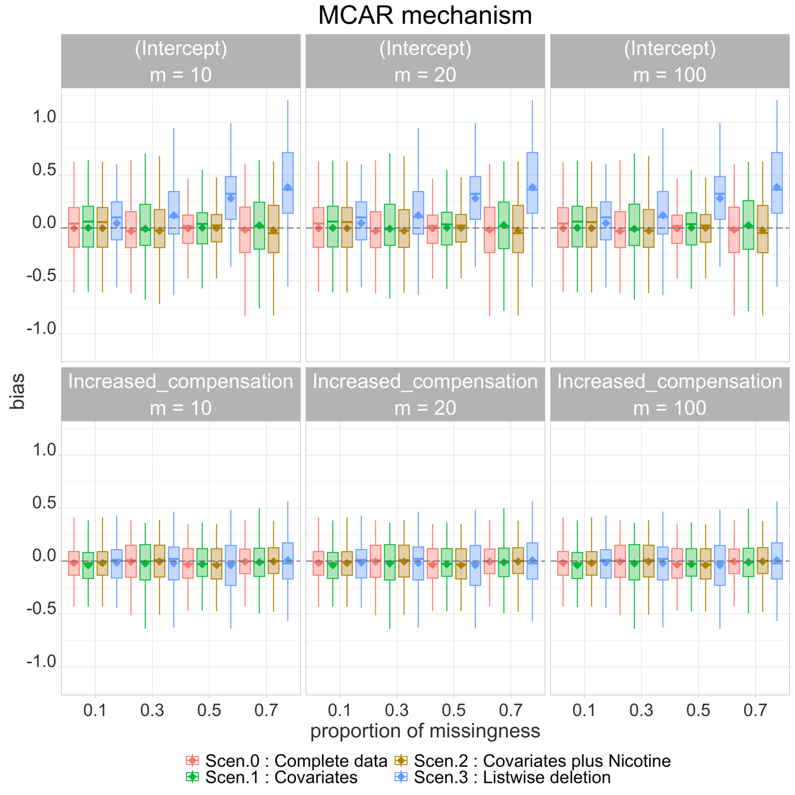

**Fig. S.4.1.1:** Bias (between estimates of each scenario and true estimates (straight line is median bias and the diamonds show the mean) for scenario 0: “complete data”, scenario 1: “Covariates” (using our method), scenario 2: “Covariates plus Nicotine” (using our method) and scenario 3: “Listwise deletion” for intercept and increased compensation for the simulation study where missingness is 0.1, 0.3, 0.5, 0.7, m (number of Imputations) = 10, 20 and 100 and data are MCAR.

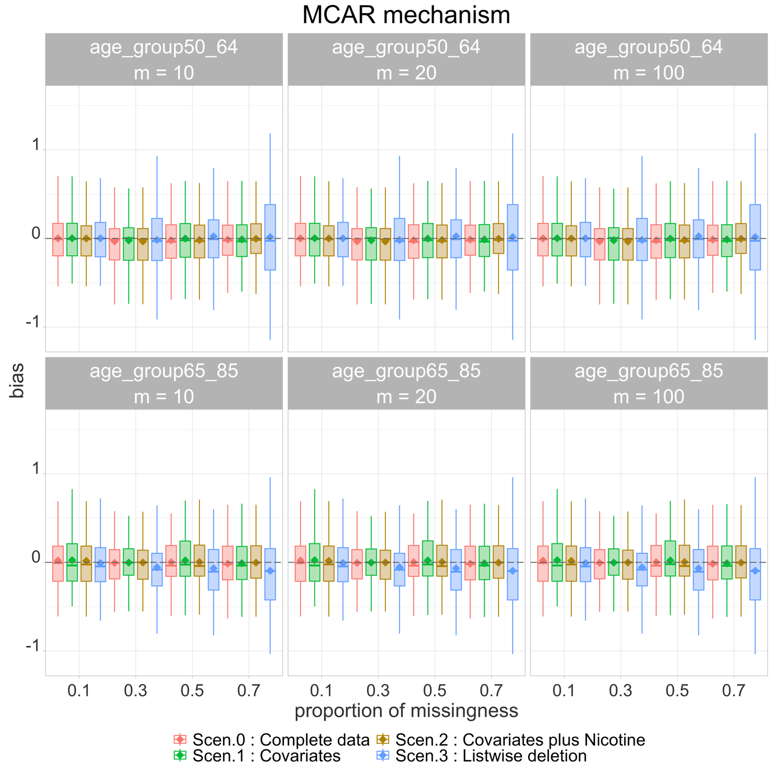

**Fig. S.4.1.2:** Bias (between estimates of each scenario and true estimates (straight line is median bias and the diamonds show the mean) for scenario 0: “complete data”, scenario 1: “Covariates” (using our method), scenario 2: “Covariates plus Nicotine” (using our method) and scenario 3: “Listwise deletion” for age-group 50-64 and age-group 65-85 for the simulation study where missingness is 0.1, 0.3, 0.5, 0.7, m (number of Imputations) = 10, 20 and 100 and data are MCAR.



**Fig. S.4.1.3:** Bias (between estimates of each scenario and true estimates (straight line is median bias and the diamonds show the mean) for scenario 0: “complete data”, scenario 1: “Covariates” (using our method), scenario 2: “Covariates plus Nicotine” (using our method) and scenario 3: “Listwise deletion” for cardiovascular disease and diabetes for the simulation study where missingness is 0.1, 0.3, 0.5, 0.7, m (number of Imputations) = 10, 20 and 100 and data are MCAR.

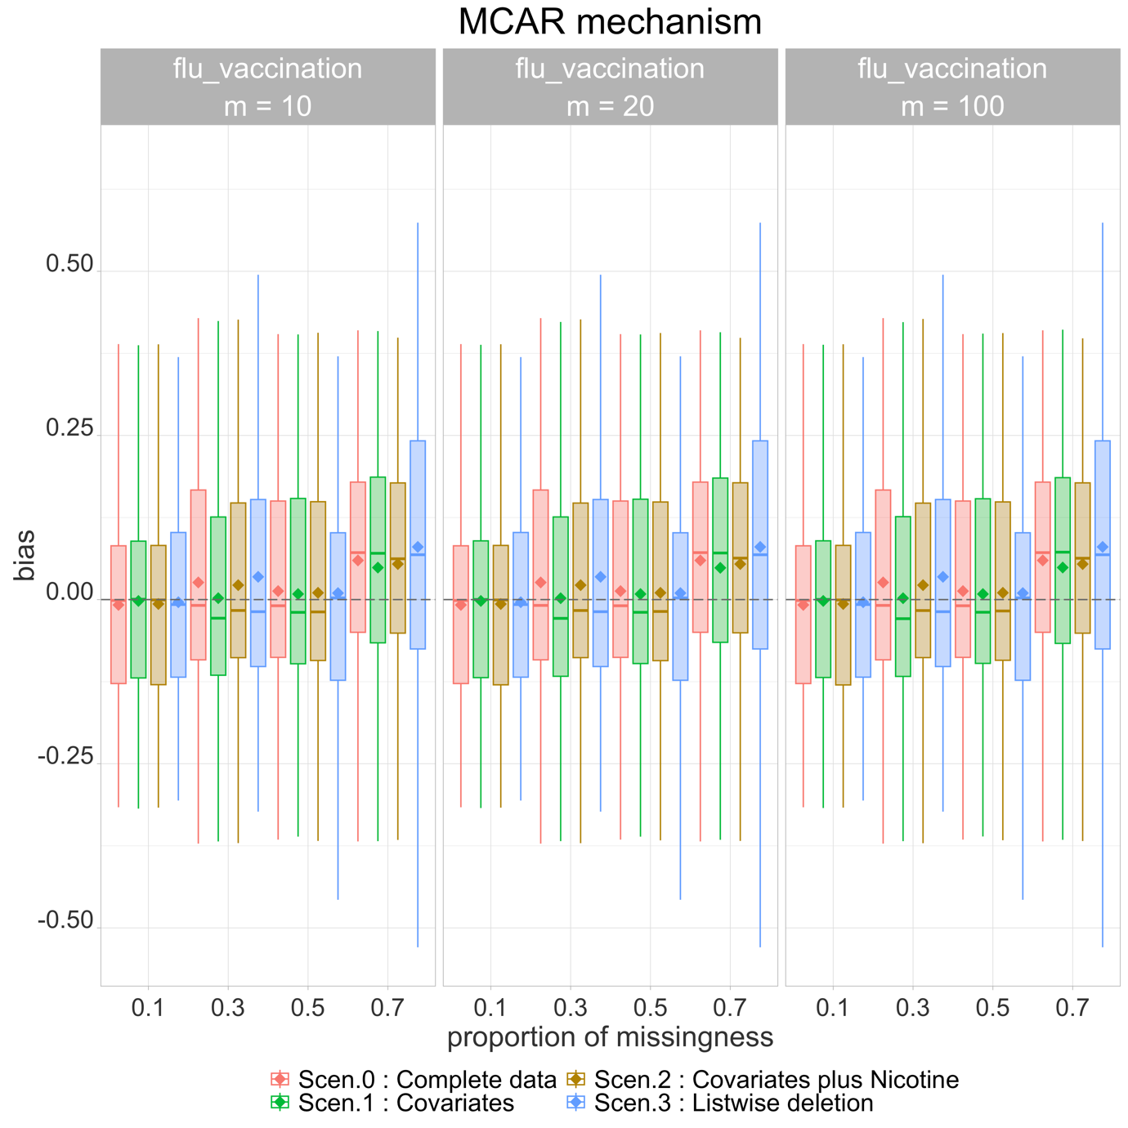

**Fig. S.4.1.4:** Bias (between estimates of each scenario and true estimates (straight line is median bias and the diamonds show the mean) for scenario 0: “complete data”, scenario 1: “Covariates” (using our method), scenario 2: “Covariates plus Nicotine” (using our method) and scenario 3: “Listwise deletion” for flu vaccination for the simulation study where missingness is 0.1, 0.3, 0.5, 0.7, m (number of Imputations) = 10, 20 and 100 and data are MCAR.

### S4.2: MNAR graphs for rest covariates

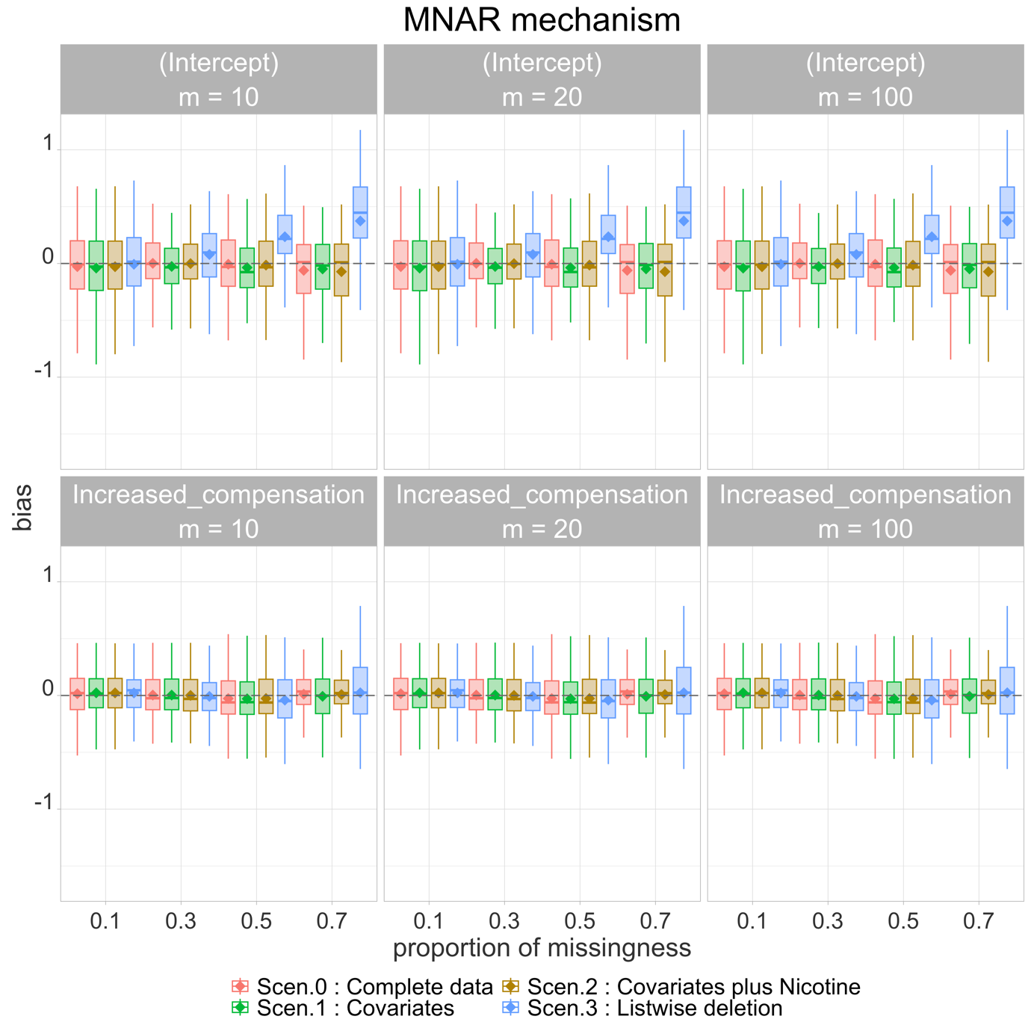

**Fig. S.4.2.1:** Bias (between estimates of each scenario and true estimates (straight line is median bias and the diamonds show the mean) for scenario 0: “complete data”, scenario 1: “Covariates” (using our method), scenario 2: “Covariates plus Nicotine” (using our method) and scenario 3: “Listwise deletion” for intercept and increased compensation for the simulation study where missingness is 0.1, 0.3, 0.5, 0.7, m (number of Imputations) = 10, 20 and 100 and data are MNAR.

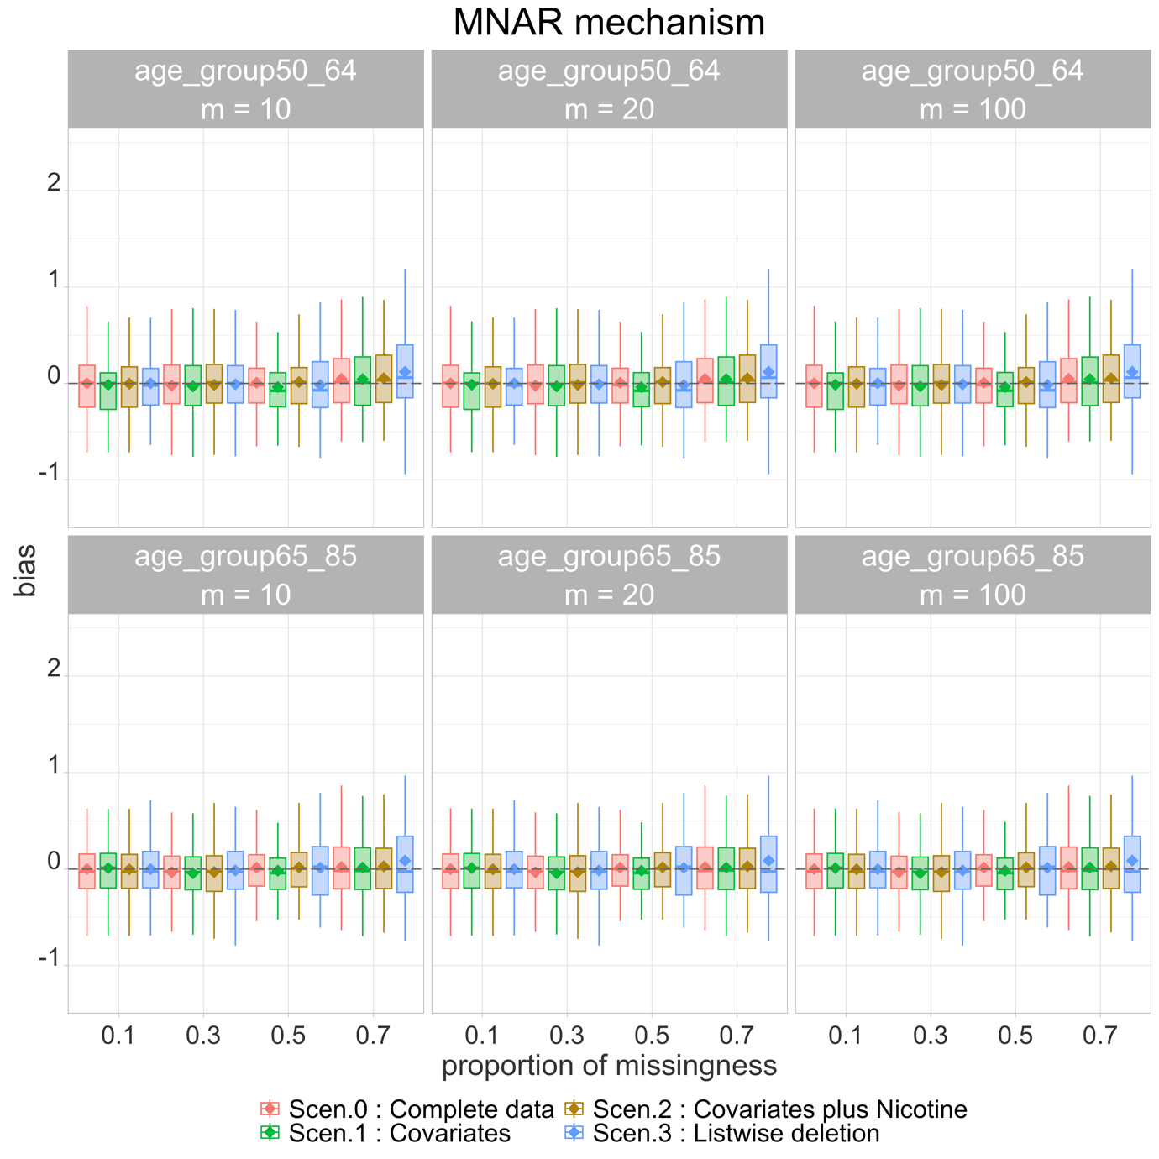

**Fig. S.4.2.2:** Bias (between estimates of each scenario and true estimates (straight line is median bias and the diamonds show the mean) for scenario 0: “complete data”, scenario 1: “Covariates” (using our method), scenario 2: “Covariates plus Nicotine” (using our method) and scenario 3: “Listwise deletion” for age-group 50-64 and age-group 65-85 for the simulation study where missingness is 0.1, 0.3, 0.5, 0.7, m (number of Imputations) = 10, 20 and 100 and data are MNAR.

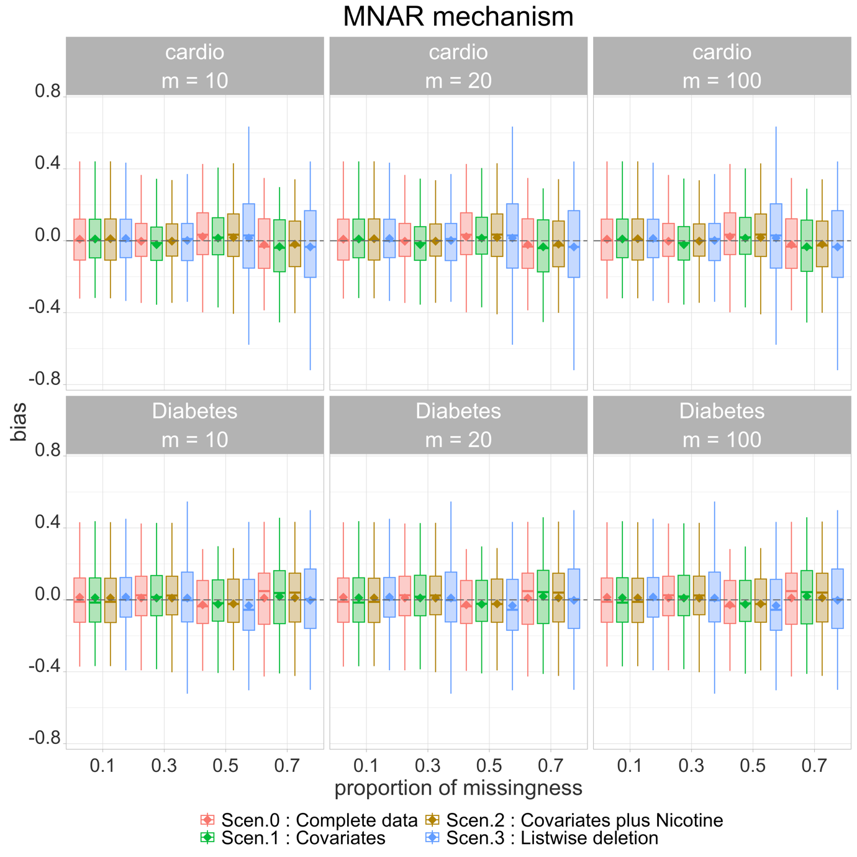

**Fig. S.4.2.3:** Bias (between estimates of each scenario and true estimates (straight line is median bias and the diamonds show the mean) for scenario 0: “complete data”, scenario 1: “Covariates” (using our method), scenario 2: “Covariates plus Nicotine” (using our method) and scenario 3: “Listwise deletion” for cardiovascular disease and diabetes for the simulation study where missingness is 0.1, 0.3, 0.5, 0.7, m (number of Imputations) = 10, 20 and 100 and data are MNAR.

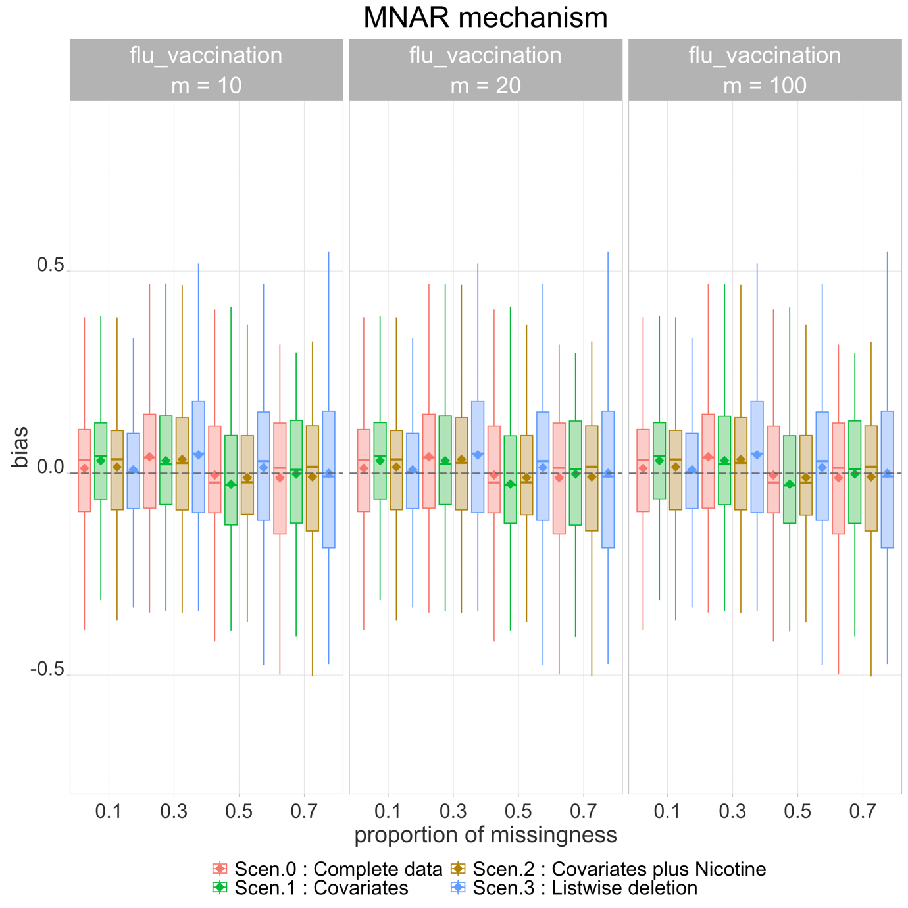

**Fig. S.4.2.4:** Bias (between estimates of each scenario and true estimates (straight line is median bias and the diamonds show the mean) for scenario 0: “complete data”, scenario 1: “Covariates” (using our method), scenario 2: “Covariates plus Nicotine” (using our method) and scenario 3: “Listwise deletion” for flu vaccination for the simulation study where missingness is 0.1, 0.3, 0.5, 0.7, m (number of Imputations) = 10, 20 and 100 and data are MNAR.

### S4.3: RMSE graphs for rest covariates

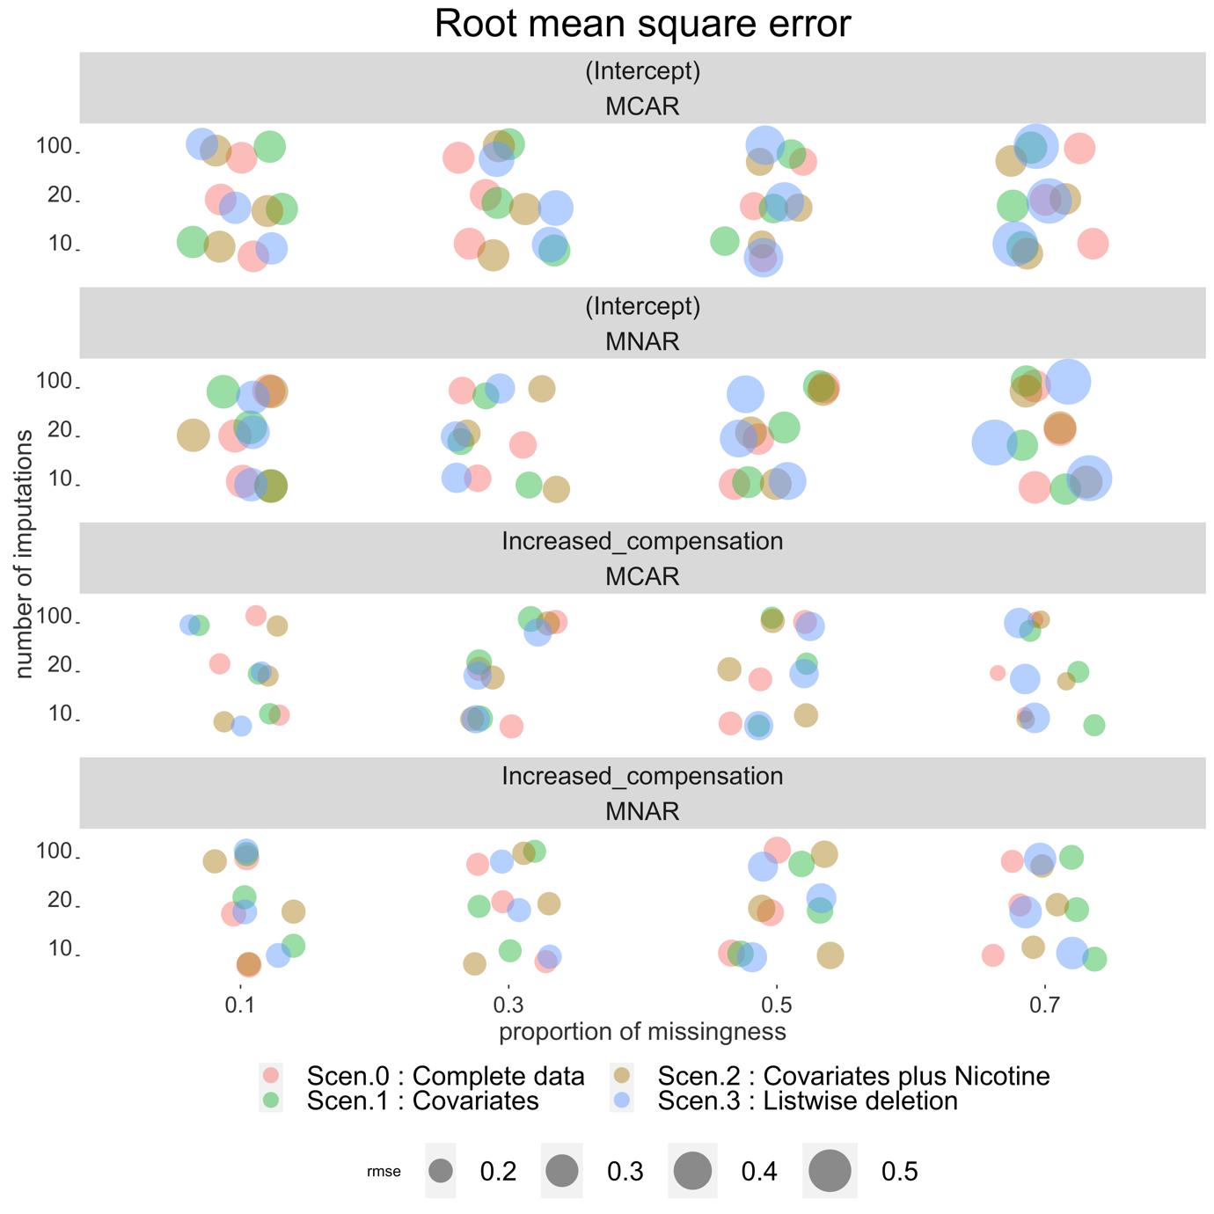

**Fig. S.4.3.1:** RMSE for scenario 0: “complete data”, scenario 1: “Covariates” (using our method), scenario 2: “Covariates plus Nicotine” (using our method) and scenario 3: “Listwise deletion” for intercept and increased compensation for the simulation study where missingness is 0.1, 0.3, 0.5, 0.7, m (number of Imputations) = 10, 20 and 100 and data are MCAR or MNAR.

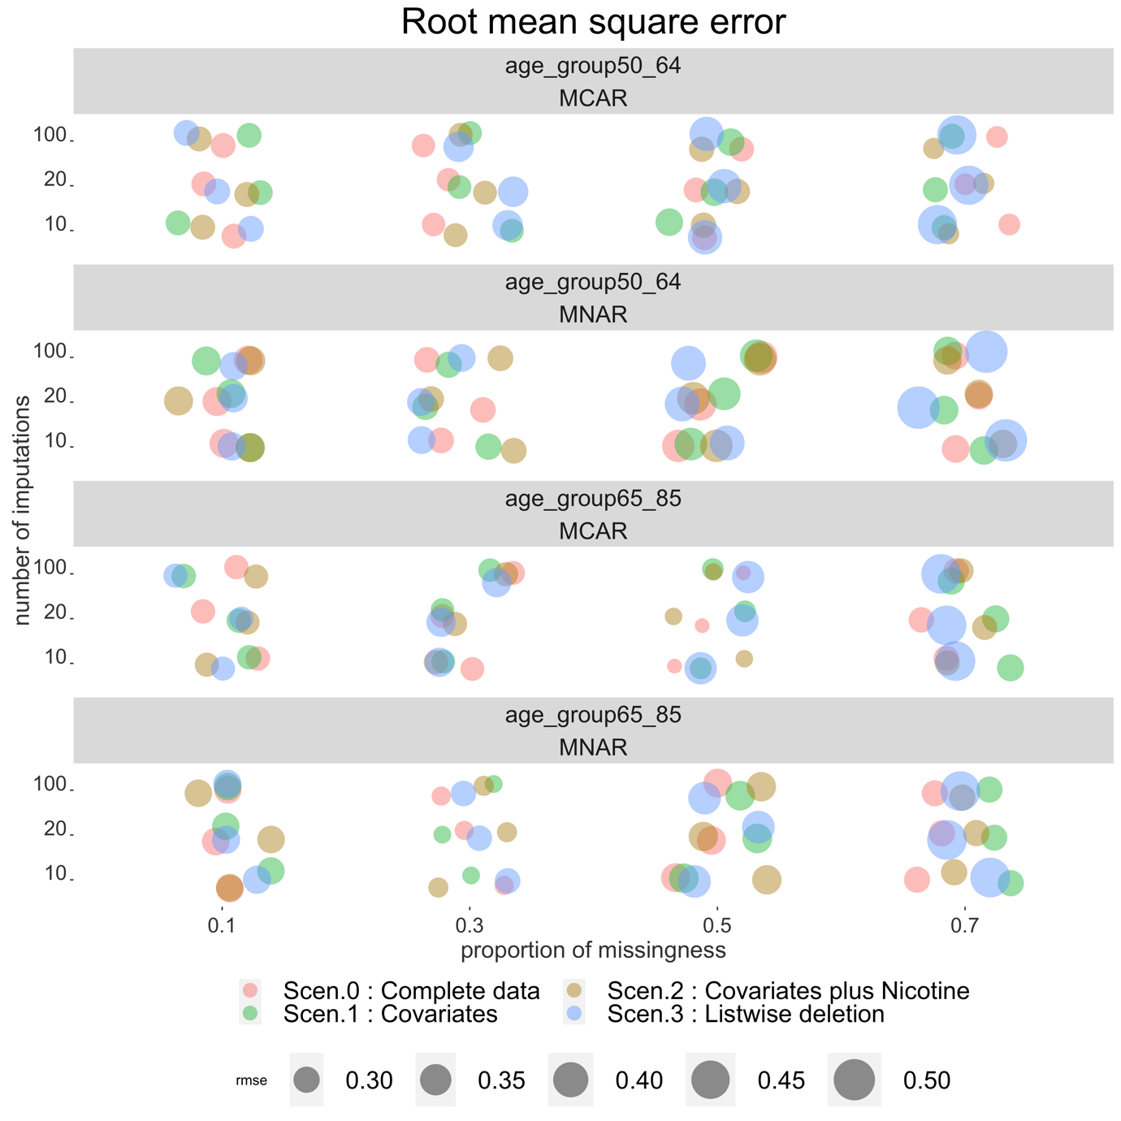

**Fig. S.4.3.2:** RMSE for scenario 0: “complete data”, scenario 1: “Covariates” (using our method), scenario 2: “Covariates plus Nicotine” (using our method) and scenario 3: “Listwise deletion” for age-group 50-64 and age-group 65-85 for the simulation study where missingness is 0.1, 0.3, 0.5, 0.7, m (number of Imputations) = 10, 20 and 100 and data are MCAR or MNAR

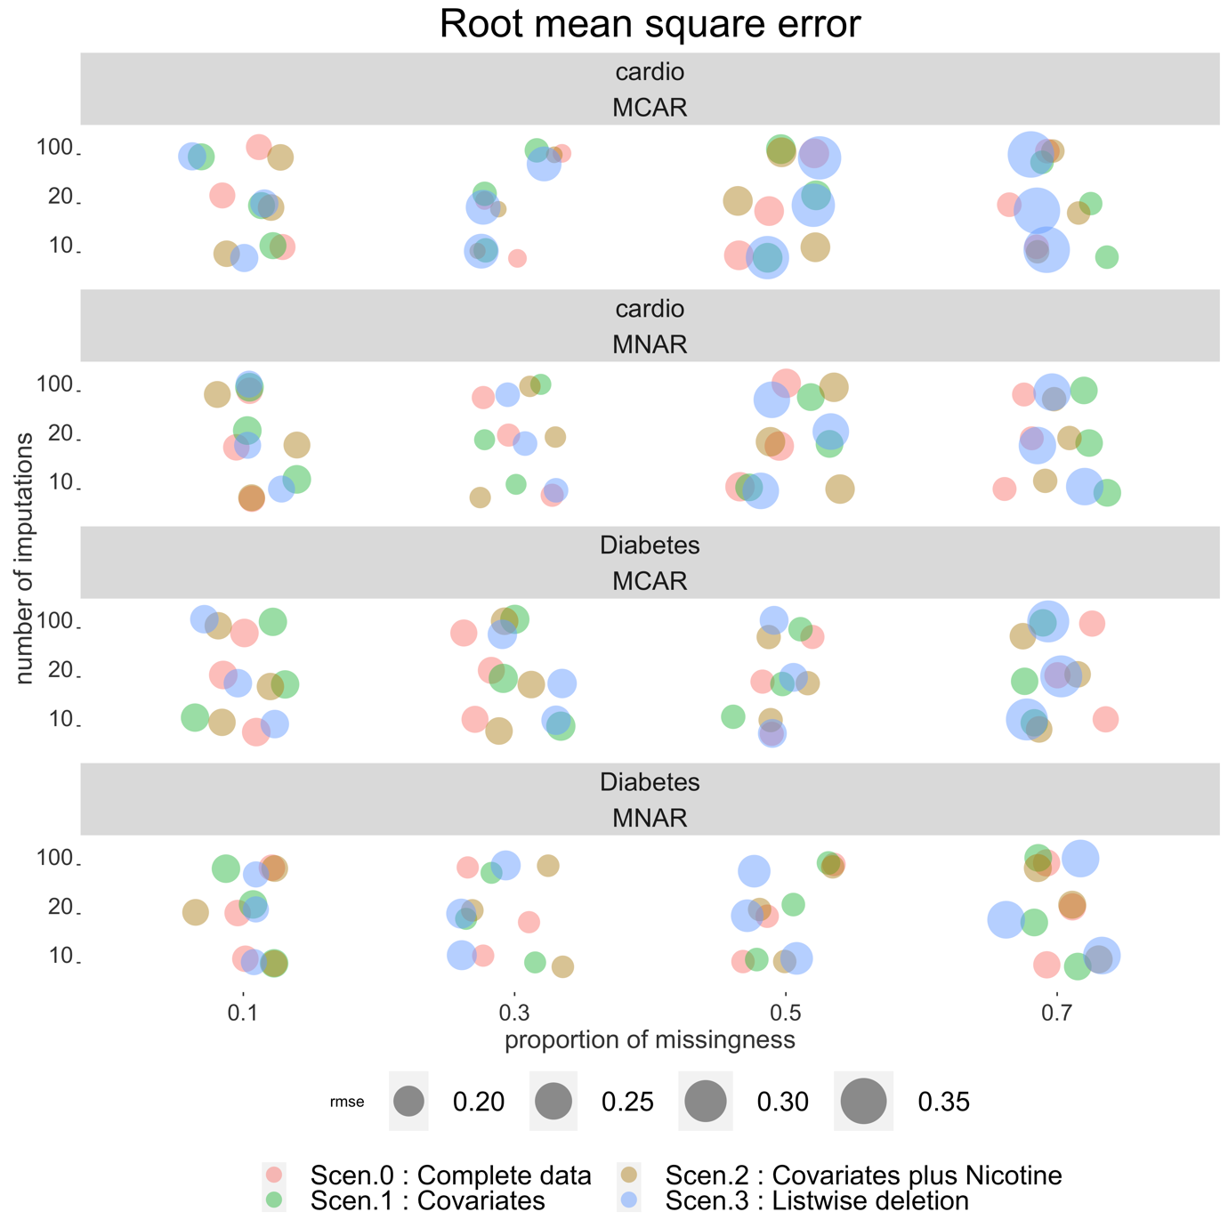

**Fig. S.4.3.3:** RMSE for scenario 0: “complete data”, scenario 1: “Covariates” (using our method), scenario 2: “Covariates plus Nicotine” (using our method) and scenario 3: “Listwise deletion” for cardiovascular disease and diabetes for the simulation study where missingness is 0.1, 0.3, 0.5, 0.7, m (number of Imputations) = 10, 20 and 100 and data are MCAR or MNAR

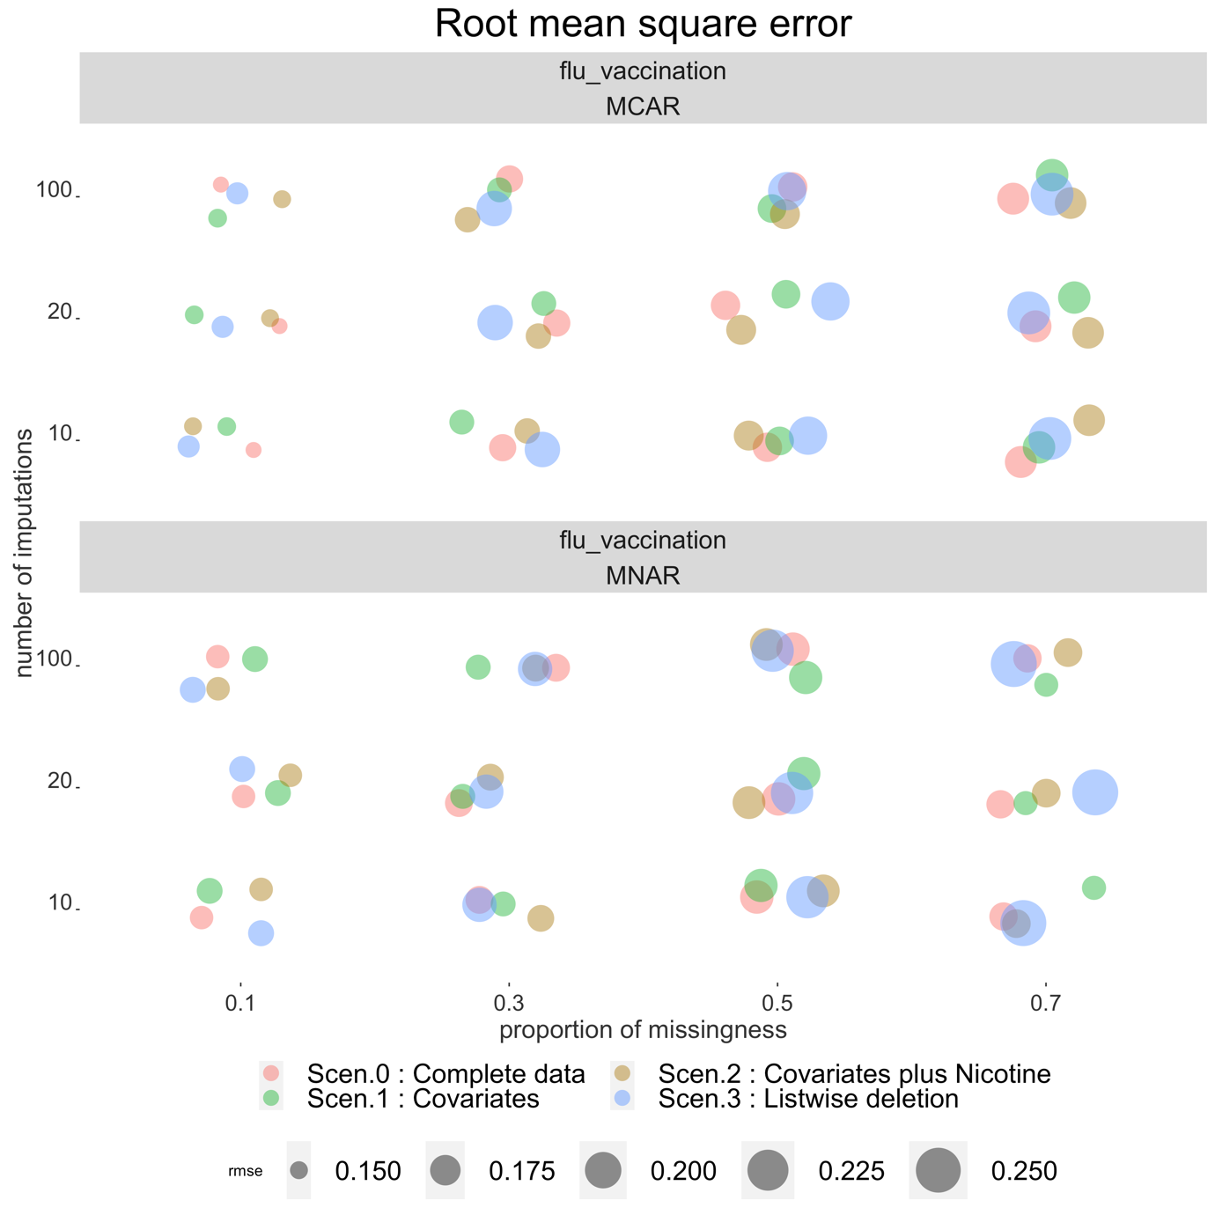

**Fig. S.4.3.4:** RMSE for scenario 0: “complete data”, scenario 1: “Covariates” (using our method), scenario 2: “Covariates plus Nicotine” (using our method) and scenario 3: “Listwise deletion” for flu vaccination for the simulation study where missingness is 0.1, 0.3, 0.5, 0.7, m (number of Imputations) = 10, 20 and 100 and data are MCAR or MNAR

## S5: RMSE table

**Table S5.1**: RMSE for current-smoker and ex-smoker versus never-smoker for all imputations, mechanisms, proportions of missingness and scenarios.

| Imputations | Mechanism | prop_mis | term | Scenario | RMSE |
| --- | --- | --- | --- | --- | --- |
| m = 10 | MCAR | 0.1 | smokingex-smoker | Scen.0 : Complete data | 0.1559676 |
| m = 10 | MCAR | 0.1 | smokingex-smoker | Scen.1 : Covariates | 0.1471065 |
| m = 10 | MCAR | 0.1 | smokingex-smoker | Scen.2 : Covariates plus Nicotine | 0.1583902 |
| m = 10 | MCAR | 0.1 | smokingex-smoker | Scen.3 : Listwise deletion | 0.1573303 |
| m = 10 | MCAR | 0.1 | smokingsmoker | Scen.0 : Complete data | 0.2014299 |
| m = 10 | MCAR | 0.1 | smokingsmoker | Scen.1 : Covariates | 0.1887277 |
| m = 10 | MCAR | 0.1 | smokingsmoker | Scen.2 : Covariates plus Nicotine | 0.1988113 |
| m = 10 | MCAR | 0.1 | smokingsmoker | Scen.3 : Listwise deletion | 0.2072991 |
| m = 10 | MCAR | 0.3 | smokingex-smoker | Scen.0 : Complete data | 0.1763704 |
| m = 10 | MCAR | 0.3 | smokingex-smoker | Scen.1 : Covariates | 0.1715165 |
| m = 10 | MCAR | 0.3 | smokingex-smoker | Scen.2 : Covariates plus Nicotine | 0.1714223 |
| m = 10 | MCAR | 0.3 | smokingex-smoker | Scen.3 : Listwise deletion | 0.2024995 |
| m = 10 | MCAR | 0.3 | smokingsmoker | Scen.0 : Complete data | 0.2139845 |
| m = 10 | MCAR | 0.3 | smokingsmoker | Scen.1 : Covariates | 0.2086345 |
| m = 10 | MCAR | 0.3 | smokingsmoker | Scen.2 : Covariates plus Nicotine | 0.2164311 |
| m = 10 | MCAR | 0.3 | smokingsmoker | Scen.3 : Listwise deletion | 0.2401947 |
| m = 10 | MCAR | 0.5 | smokingex-smoker | Scen.0 : Complete data | 0.1779116 |
| m = 10 | MCAR | 0.5 | smokingex-smoker | Scen.1 : Covariates | 0.1791786 |
| m = 10 | MCAR | 0.5 | smokingex-smoker | Scen.2 : Covariates plus Nicotine | 0.1788667 |
| m = 10 | MCAR | 0.5 | smokingex-smoker | Scen.3 : Listwise deletion | 0.2304771 |
| m = 10 | MCAR | 0.5 | smokingsmoker | Scen.0 : Complete data | 0.1969667 |
| m = 10 | MCAR | 0.5 | smokingsmoker | Scen.1 : Covariates | 0.1993462 |
| m = 10 | MCAR | 0.5 | smokingsmoker | Scen.2 : Covariates plus Nicotine | 0.1951748 |
| m = 10 | MCAR | 0.5 | smokingsmoker | Scen.3 : Listwise deletion | 0.2620339 |
| m = 10 | MCAR | 0.7 | smokingex-smoker | Scen.0 : Complete data | 0.1762426 |
| m = 10 | MCAR | 0.7 | smokingex-smoker | Scen.1 : Covariates | 0.1796989 |
| m = 10 | MCAR | 0.7 | smokingex-smoker | Scen.2 : Covariates plus Nicotine | 0.1736139 |
| m = 10 | MCAR | 0.7 | smokingex-smoker | Scen.3 : Listwise deletion | 0.2677669 |
| m = 10 | MCAR | 0.7 | smokingsmoker | Scen.0 : Complete data | 0.2097225 |
| m = 10 | MCAR | 0.7 | smokingsmoker | Scen.1 : Covariates | 0.1832811 |
| m = 10 | MCAR | 0.7 | smokingsmoker | Scen.2 : Covariates plus Nicotine | 0.2097268 |
| m = 10 | MCAR | 0.7 | smokingsmoker | Scen.3 : Listwise deletion | 0.3171263 |
| m = 10 | MNAR | 0.1 | smokingex-smoker | Scen.0 : Complete data | 0.1945400 |
| m = 10 | MNAR | 0.1 | smokingex-smoker | Scen.1 : Covariates | 0.1959167 |
| m = 10 | MNAR | 0.1 | smokingex-smoker | Scen.2 : Covariates plus Nicotine | 0.1942722 |
| m = 10 | MNAR | 0.1 | smokingex-smoker | Scen.3 : Listwise deletion | 0.2344486 |
| m = 10 | MNAR | 0.1 | smokingsmoker | Scen.0 : Complete data | 0.2216469 |
| m = 10 | MNAR | 0.1 | smokingsmoker | Scen.1 : Covariates | 0.2270356 |
| m = 10 | MNAR | 0.1 | smokingsmoker | Scen.2 : Covariates plus Nicotine | 0.2223596 |
| m = 10 | MNAR | 0.1 | smokingsmoker | Scen.3 : Listwise deletion | 0.2396365 |
| m = 10 | MNAR | 0.3 | smokingex-smoker | Scen.0 : Complete data | 0.1874538 |
| m = 10 | MNAR | 0.3 | smokingex-smoker | Scen.1 : Covariates | 0.2012758 |
| m = 10 | MNAR | 0.3 | smokingex-smoker | Scen.2 : Covariates plus Nicotine | 0.1883445 |
| m = 10 | MNAR | 0.3 | smokingex-smoker | Scen.3 : Listwise deletion | 0.4412156 |
| m = 10 | MNAR | 0.3 | smokingsmoker | Scen.0 : Complete data | 0.2158808 |
| m = 10 | MNAR | 0.3 | smokingsmoker | Scen.1 : Covariates | 0.2273248 |
| m = 10 | MNAR | 0.3 | smokingsmoker | Scen.2 : Covariates plus Nicotine | 0.2160030 |
| m = 10 | MNAR | 0.3 | smokingsmoker | Scen.3 : Listwise deletion | 0.4293932 |
| m = 10 | MNAR | 0.5 | smokingex-smoker | Scen.0 : Complete data | 0.1777312 |
| m = 10 | MNAR | 0.5 | smokingex-smoker | Scen.1 : Covariates | 0.2455171 |
| m = 10 | MNAR | 0.5 | smokingex-smoker | Scen.2 : Covariates plus Nicotine | 0.1775617 |
| m = 10 | MNAR | 0.5 | smokingex-smoker | Scen.3 : Listwise deletion | 0.6145222 |
| m = 10 | MNAR | 0.5 | smokingsmoker | Scen.0 : Complete data | 0.2121731 |
| m = 10 | MNAR | 0.5 | smokingsmoker | Scen.1 : Covariates | 0.3238956 |
| m = 10 | MNAR | 0.5 | smokingsmoker | Scen.2 : Covariates plus Nicotine | 0.2053854 |
| m = 10 | MNAR | 0.5 | smokingsmoker | Scen.3 : Listwise deletion | 0.7020537 |
| m = 10 | MNAR | 0.7 | smokingex-smoker | Scen.0 : Complete data | 0.1707266 |
| m = 10 | MNAR | 0.7 | smokingex-smoker | Scen.1 : Covariates | 0.2664960 |
| m = 10 | MNAR | 0.7 | smokingex-smoker | Scen.2 : Covariates plus Nicotine | 0.1780095 |
| m = 10 | MNAR | 0.7 | smokingex-smoker | Scen.3 : Listwise deletion | 0.7564238 |
| m = 10 | MNAR | 0.7 | smokingsmoker | Scen.0 : Complete data | 0.1926144 |
| m = 10 | MNAR | 0.7 | smokingsmoker | Scen.1 : Covariates | 0.2954208 |
| m = 10 | MNAR | 0.7 | smokingsmoker | Scen.2 : Covariates plus Nicotine | 0.1990738 |
| m = 10 | MNAR | 0.7 | smokingsmoker | Scen.3 : Listwise deletion | 0.7512207 |
| m = 20 | MCAR | 0.1 | smokingex-smoker | Scen.0 : Complete data | 0.1559676 |
| m = 20 | MCAR | 0.1 | smokingex-smoker | Scen.1 : Covariates | 0.1468185 |
| m = 20 | MCAR | 0.1 | smokingex-smoker | Scen.2 : Covariates plus Nicotine | 0.1582443 |
| m = 20 | MCAR | 0.1 | smokingex-smoker | Scen.3 : Listwise deletion | 0.1573303 |
| m = 20 | MCAR | 0.1 | smokingsmoker | Scen.0 : Complete data | 0.2014299 |
| m = 20 | MCAR | 0.1 | smokingsmoker | Scen.1 : Covariates | 0.1889606 |
| m = 20 | MCAR | 0.1 | smokingsmoker | Scen.2 : Covariates plus Nicotine | 0.1991375 |
| m = 20 | MCAR | 0.1 | smokingsmoker | Scen.3 : Listwise deletion | 0.2072991 |
| m = 20 | MCAR | 0.3 | smokingex-smoker | Scen.0 : Complete data | 0.1763704 |
| m = 20 | MCAR | 0.3 | smokingex-smoker | Scen.1 : Covariates | 0.1709020 |
| m = 20 | MCAR | 0.3 | smokingex-smoker | Scen.2 : Covariates plus Nicotine | 0.1713784 |
| m = 20 | MCAR | 0.3 | smokingex-smoker | Scen.3 : Listwise deletion | 0.2024995 |
| m = 20 | MCAR | 0.3 | smokingsmoker | Scen.0 : Complete data | 0.2139845 |
| m = 20 | MCAR | 0.3 | smokingsmoker | Scen.1 : Covariates | 0.2081822 |
| m = 20 | MCAR | 0.3 | smokingsmoker | Scen.2 : Covariates plus Nicotine | 0.2160326 |
| m = 20 | MCAR | 0.3 | smokingsmoker | Scen.3 : Listwise deletion | 0.2401947 |
| m = 20 | MCAR | 0.5 | smokingex-smoker | Scen.0 : Complete data | 0.1779116 |
| m = 20 | MCAR | 0.5 | smokingex-smoker | Scen.1 : Covariates | 0.1774952 |
| m = 20 | MCAR | 0.5 | smokingex-smoker | Scen.2 : Covariates plus Nicotine | 0.1785576 |
| m = 20 | MCAR | 0.5 | smokingex-smoker | Scen.3 : Listwise deletion | 0.2304771 |
| m = 20 | MCAR | 0.5 | smokingsmoker | Scen.0 : Complete data | 0.1969667 |
| m = 20 | MCAR | 0.5 | smokingsmoker | Scen.1 : Covariates | 0.1966382 |
| m = 20 | MCAR | 0.5 | smokingsmoker | Scen.2 : Covariates plus Nicotine | 0.1950309 |
| m = 20 | MCAR | 0.5 | smokingsmoker | Scen.3 : Listwise deletion | 0.2620339 |
| m = 20 | MCAR | 0.7 | smokingex-smoker | Scen.0 : Complete data | 0.1762426 |
| m = 20 | MCAR | 0.7 | smokingex-smoker | Scen.1 : Covariates | 0.1767588 |
| m = 20 | MCAR | 0.7 | smokingex-smoker | Scen.2 : Covariates plus Nicotine | 0.1732279 |
| m = 20 | MCAR | 0.7 | smokingex-smoker | Scen.3 : Listwise deletion | 0.2677669 |
| m = 20 | MCAR | 0.7 | smokingsmoker | Scen.0 : Complete data | 0.2097225 |
| m = 20 | MCAR | 0.7 | smokingsmoker | Scen.1 : Covariates | 0.1817031 |
| m = 20 | MCAR | 0.7 | smokingsmoker | Scen.2 : Covariates plus Nicotine | 0.2082098 |
| m = 20 | MCAR | 0.7 | smokingsmoker | Scen.3 : Listwise deletion | 0.3171263 |
| m = 20 | MNAR | 0.1 | smokingex-smoker | Scen.0 : Complete data | 0.1945400 |
| m = 20 | MNAR | 0.1 | smokingex-smoker | Scen.1 : Covariates | 0.1954062 |
| m = 20 | MNAR | 0.1 | smokingex-smoker | Scen.2 : Covariates plus Nicotine | 0.1942770 |
| m = 20 | MNAR | 0.1 | smokingex-smoker | Scen.3 : Listwise deletion | 0.2344486 |
| m = 20 | MNAR | 0.1 | smokingsmoker | Scen.0 : Complete data | 0.2216469 |
| m = 20 | MNAR | 0.1 | smokingsmoker | Scen.1 : Covariates | 0.2278644 |
| m = 20 | MNAR | 0.1 | smokingsmoker | Scen.2 : Covariates plus Nicotine | 0.2228923 |
| m = 20 | MNAR | 0.1 | smokingsmoker | Scen.3 : Listwise deletion | 0.2396365 |
| m = 20 | MNAR | 0.3 | smokingex-smoker | Scen.0 : Complete data | 0.1874538 |
| m = 20 | MNAR | 0.3 | smokingex-smoker | Scen.1 : Covariates | 0.2006985 |
| m = 20 | MNAR | 0.3 | smokingex-smoker | Scen.2 : Covariates plus Nicotine | 0.1883997 |
| m = 20 | MNAR | 0.3 | smokingex-smoker | Scen.3 : Listwise deletion | 0.4412156 |
| m = 20 | MNAR | 0.3 | smokingsmoker | Scen.0 : Complete data | 0.2158808 |
| m = 20 | MNAR | 0.3 | smokingsmoker | Scen.1 : Covariates | 0.2254489 |
| m = 20 | MNAR | 0.3 | smokingsmoker | Scen.2 : Covariates plus Nicotine | 0.2156003 |
| m = 20 | MNAR | 0.3 | smokingsmoker | Scen.3 : Listwise deletion | 0.4293932 |
| m = 20 | MNAR | 0.5 | smokingex-smoker | Scen.0 : Complete data | 0.1777312 |
| m = 20 | MNAR | 0.5 | smokingex-smoker | Scen.1 : Covariates | 0.2468567 |
| m = 20 | MNAR | 0.5 | smokingex-smoker | Scen.2 : Covariates plus Nicotine | 0.1775604 |
| m = 20 | MNAR | 0.5 | smokingex-smoker | Scen.3 : Listwise deletion | 0.6145222 |
| m = 20 | MNAR | 0.5 | smokingsmoker | Scen.0 : Complete data | 0.2121731 |
| m = 20 | MNAR | 0.5 | smokingsmoker | Scen.1 : Covariates | 0.3266129 |
| m = 20 | MNAR | 0.5 | smokingsmoker | Scen.2 : Covariates plus Nicotine | 0.2051477 |
| m = 20 | MNAR | 0.5 | smokingsmoker | Scen.3 : Listwise deletion | 0.7020537 |
| m = 20 | MNAR | 0.7 | smokingex-smoker | Scen.0 : Complete data | 0.1707266 |
| m = 20 | MNAR | 0.7 | smokingex-smoker | Scen.1 : Covariates | 0.2608629 |
| m = 20 | MNAR | 0.7 | smokingex-smoker | Scen.2 : Covariates plus Nicotine | 0.1781738 |
| m = 20 | MNAR | 0.7 | smokingex-smoker | Scen.3 : Listwise deletion | 0.7564238 |
| m = 20 | MNAR | 0.7 | smokingsmoker | Scen.0 : Complete data | 0.1926144 |
| m = 20 | MNAR | 0.7 | smokingsmoker | Scen.1 : Covariates | 0.2934514 |
| m = 20 | MNAR | 0.7 | smokingsmoker | Scen.2 : Covariates plus Nicotine | 0.1978865 |
| m = 20 | MNAR | 0.7 | smokingsmoker | Scen.3 : Listwise deletion | 0.7512207 |
| m = 100 | MCAR | 0.1 | smokingex-smoker | Scen.0 : Complete data | 0.1559676 |
| m = 100 | MCAR | 0.1 | smokingex-smoker | Scen.1 : Covariates | 0.1472758 |
| m = 100 | MCAR | 0.1 | smokingex-smoker | Scen.2 : Covariates plus Nicotine | 0.1588147 |
| m = 100 | MCAR | 0.1 | smokingex-smoker | Scen.3 : Listwise deletion | 0.1573303 |
| m = 100 | MCAR | 0.1 | smokingsmoker | Scen.0 : Complete data | 0.2014299 |
| m = 100 | MCAR | 0.1 | smokingsmoker | Scen.1 : Covariates | 0.1882131 |
| m = 100 | MCAR | 0.1 | smokingsmoker | Scen.2 : Covariates plus Nicotine | 0.1995945 |
| m = 100 | MCAR | 0.1 | smokingsmoker | Scen.3 : Listwise deletion | 0.2072991 |
| m = 100 | MCAR | 0.3 | smokingex-smoker | Scen.0 : Complete data | 0.1763704 |
| m = 100 | MCAR | 0.3 | smokingex-smoker | Scen.1 : Covariates | 0.1712944 |
| m = 100 | MCAR | 0.3 | smokingex-smoker | Scen.2 : Covariates plus Nicotine | 0.1716237 |
| m = 100 | MCAR | 0.3 | smokingex-smoker | Scen.3 : Listwise deletion | 0.2024995 |
| m = 100 | MCAR | 0.3 | smokingsmoker | Scen.0 : Complete data | 0.2139845 |
| m = 100 | MCAR | 0.3 | smokingsmoker | Scen.1 : Covariates | 0.2078618 |
| m = 100 | MCAR | 0.3 | smokingsmoker | Scen.2 : Covariates plus Nicotine | 0.2167421 |
| m = 100 | MCAR | 0.3 | smokingsmoker | Scen.3 : Listwise deletion | 0.2401947 |
| m = 100 | MCAR | 0.5 | smokingex-smoker | Scen.0 : Complete data | 0.1779116 |
| m = 100 | MCAR | 0.5 | smokingex-smoker | Scen.1 : Covariates | 0.1757052 |
| m = 100 | MCAR | 0.5 | smokingex-smoker | Scen.2 : Covariates plus Nicotine | 0.1785050 |
| m = 100 | MCAR | 0.5 | smokingex-smoker | Scen.3 : Listwise deletion | 0.2304771 |
| m = 100 | MCAR | 0.5 | smokingsmoker | Scen.0 : Complete data | 0.1969667 |
| m = 100 | MCAR | 0.5 | smokingsmoker | Scen.1 : Covariates | 0.1955318 |
| m = 100 | MCAR | 0.5 | smokingsmoker | Scen.2 : Covariates plus Nicotine | 0.1939633 |
| m = 100 | MCAR | 0.5 | smokingsmoker | Scen.3 : Listwise deletion | 0.2620339 |
| m = 100 | MCAR | 0.7 | smokingex-smoker | Scen.0 : Complete data | 0.1762426 |
| m = 100 | MCAR | 0.7 | smokingex-smoker | Scen.1 : Covariates | 0.1743276 |
| m = 100 | MCAR | 0.7 | smokingex-smoker | Scen.2 : Covariates plus Nicotine | 0.1729229 |
| m = 100 | MCAR | 0.7 | smokingex-smoker | Scen.3 : Listwise deletion | 0.2677669 |
| m = 100 | MCAR | 0.7 | smokingsmoker | Scen.0 : Complete data | 0.2097225 |
| m = 100 | MCAR | 0.7 | smokingsmoker | Scen.1 : Covariates | 0.1809646 |
| m = 100 | MCAR | 0.7 | smokingsmoker | Scen.2 : Covariates plus Nicotine | 0.2079396 |
| m = 100 | MCAR | 0.7 | smokingsmoker | Scen.3 : Listwise deletion | 0.3171263 |
| m = 100 | MNAR | 0.1 | smokingex-smoker | Scen.0 : Complete data | 0.1945400 |
| m = 100 | MNAR | 0.1 | smokingex-smoker | Scen.1 : Covariates | 0.1951570 |
| m = 100 | MNAR | 0.1 | smokingex-smoker | Scen.2 : Covariates plus Nicotine | 0.1940352 |
| m = 100 | MNAR | 0.1 | smokingex-smoker | Scen.3 : Listwise deletion | 0.2344486 |
| m = 100 | MNAR | 0.1 | smokingsmoker | Scen.0 : Complete data | 0.2216469 |
| m = 100 | MNAR | 0.1 | smokingsmoker | Scen.1 : Covariates | 0.2273897 |
| m = 100 | MNAR | 0.1 | smokingsmoker | Scen.2 : Covariates plus Nicotine | 0.2228622 |
| m = 100 | MNAR | 0.1 | smokingsmoker | Scen.3 : Listwise deletion | 0.2396365 |
| m = 100 | MNAR | 0.3 | smokingex-smoker | Scen.0 : Complete data | 0.1874538 |
| m = 100 | MNAR | 0.3 | smokingex-smoker | Scen.1 : Covariates | 0.2010825 |
| m = 100 | MNAR | 0.3 | smokingex-smoker | Scen.2 : Covariates plus Nicotine | 0.1886106 |
| m = 100 | MNAR | 0.3 | smokingex-smoker | Scen.3 : Listwise deletion | 0.4412156 |
| m = 100 | MNAR | 0.3 | smokingsmoker | Scen.0 : Complete data | 0.2158808 |
| m = 100 | MNAR | 0.3 | smokingsmoker | Scen.1 : Covariates | 0.2259320 |
| m = 100 | MNAR | 0.3 | smokingsmoker | Scen.2 : Covariates plus Nicotine | 0.2152913 |
| m = 100 | MNAR | 0.3 | smokingsmoker | Scen.3 : Listwise deletion | 0.4293932 |
| m = 100 | MNAR | 0.5 | smokingex-smoker | Scen.0 : Complete data | 0.1777312 |
| m = 100 | MNAR | 0.5 | smokingex-smoker | Scen.1 : Covariates | 0.2460424 |
| m = 100 | MNAR | 0.5 | smokingex-smoker | Scen.2 : Covariates plus Nicotine | 0.1771943 |
| m = 100 | MNAR | 0.5 | smokingex-smoker | Scen.3 : Listwise deletion | 0.6145222 |
| m = 100 | MNAR | 0.5 | smokingsmoker | Scen.0 : Complete data | 0.2121731 |
| m = 100 | MNAR | 0.5 | smokingsmoker | Scen.1 : Covariates | 0.3246791 |
| m = 100 | MNAR | 0.5 | smokingsmoker | Scen.2 : Covariates plus Nicotine | 0.2048561 |
| m = 100 | MNAR | 0.5 | smokingsmoker | Scen.3 : Listwise deletion | 0.7020537 |
| m = 100 | MNAR | 0.7 | smokingex-smoker | Scen.0 : Complete data | 0.1707266 |
| m = 100 | MNAR | 0.7 | smokingex-smoker | Scen.1 : Covariates | 0.2647762 |
| m = 100 | MNAR | 0.7 | smokingex-smoker | Scen.2 : Covariates plus Nicotine | 0.1785451 |
| m = 100 | MNAR | 0.7 | smokingex-smoker | Scen.3 : Listwise deletion | 0.7564238 |
| m = 100 | MNAR | 0.7 | smokingsmoker | Scen.0 : Complete data | 0.1926144 |
| m = 100 | MNAR | 0.7 | smokingsmoker | Scen.1 : Covariates | 0.2936976 |
| m = 100 | MNAR | 0.7 | smokingsmoker | Scen.2 : Covariates plus Nicotine | 0.1978507 |
| m = 100 | MNAR | 0.7 | smokingsmoker | Scen.3 : Listwise deletion | 0.7512207 |

## S6: Rcode

### S6.1: Generating data in wave 1

sim_Intego_start_year <- function(){  
   
 # age-group #  
 #------------------------------------#  
 sim_data <- rep(c("18_49","50_64", "65_85"), 1000*c(0.48, 0.30, 0.22) )   
 sim_data <- as.data.frame(sim_data)  
 names(sim_data) = "age_group"  
 sim_data$age50 <- ifelse(sim_data$age_group == "50_64", 1, 0)  
 sim_data$age65 <- ifelse(sim_data$age_group == "65_85", 1, 0)  
   
 # logistic function #  
 #------------------------------------#  
 logistic_fun <- function(x) exp(x)/(1 + exp(x))  
   
 # Diabetes #  
 #------------------------------------#  
 sim_data$Diabetes <- rbinom(nrow(sim_data), 1, logistic_fun(-3.500131 + 1.562484 * sim_data$age50 + 2.268631 * sim_data$age65))  
   
 # cardio #  
 #------------------------------------#  
 sim_data$cardio <- rbinom(nrow(sim_data), 1, logistic_fun(-3.9933067 + 1.7440822 * sim_data$age50 +   
 2.6195372 * sim_data$age65 + 0.7758457 * sim_data$Diabetes))  
   
 # Increased compensation #  
 #------------------------------------#  
 sim_data$Increased_compensation <- rbinom(nrow(sim_data), 1, logistic_fun(-1.7231039 + 0.5938513 * sim_data$cardio))  
   
 # Flu vaccination #  
 #------------------------------------#  
 sim_data$flu_vaccination <- rbinom(nrow(sim_data), 1, logistic_fun(-2.9090806 + 1.5329908 * sim_data$age50 + 2.9972999 * sim_data$age65 +  
 0.4177558 * sim_data$cardio + 0.2003937 * sim_data$Increased_compensation))  
   
   
 # Smoking #  
 #------------------------------------#  
 sim_data$Intercept <- 1  
 sim_datasmoking <- sim_data %>%   
 dplyr::select(-Increased_compensation) %>%   
 dplyr::select(Intercept, age50, age65, cardio, Diabetes, flu_vaccination)  
   
 sim_datasmoking <- as.matrix(sim_datasmoking)  
 names(sim_datasmoking)  
 vCoef1 = rep(0, 6)  
 vCoef2 = c(1.2325227, -0.7652041, -0.9426503, -0.63642418, -0.17292640, -0.08972528)  
 vCoef3 = c(0.6769594, -0.6368804, -1.2980136, 0.03983521, -0.06714351, -0.46152524)  
   
 vProb = cbind(exp(sim_datasmoking%*%vCoef1), exp(sim_datasmoking%*%vCoef2), exp(sim_datasmoking%*%vCoef3))  
 mChoices = t(apply(vProb, 1, rmultinom, n = 1, size = 1))  
 sim_datasmoking = cbind.data.frame(smoking = apply(mChoices, 1, function(x) which(x==1)), sim_datasmoking)  
 sim_datasmoking <- as.data.frame(sim_datasmoking)  
 sim_datasmoking$smoking <- ifelse(sim_datasmoking$smoking == 1, "ex-smoker",  
 ifelse(sim_datasmoking$smoking == 2, "never-smoker", "smoker"))  
 sim_datasmoking1 <- sim_datasmoking %>% dplyr::select(smoking)  
 sim_data <- cbind(sim_data, sim_datasmoking1)  
 sim_data$smoking <- factor(sim_data$smoking , levels = c("never-smoker", "smoker", "ex-smoker"))  
   
   
 sim_data$exsmokerInd <- ifelse(sim_data$smoking == "ex-smoker", 1, 0)  
 sim_data$smokerInd <- ifelse(sim_data$smoking == "smoker", 1, 0)  
 sim_data$neverInd <- ifelse(sim_data$smoking == "never-smoker", 1, 0)   
 # Outcome #  
 #------------------------------------#  
   
 sim_data$immunized <- rbinom(nrow(sim_data), 1, logistic_fun(-4.86651888 +  
 1.35535556 * sim_data$age50 +  
 2.74014059 * sim_data$age65+  
 0.25609517 * sim_data$Diabetes +  
 0.38834806 * sim_data$cardio +  
 0.08183779 * sim_data$Increased_compensation +  
 1.45468344 * sim_data$flu_vaccination+  
 0.29579054 * sim_data$exsmokerInd+  
 0.19961800 * sim_data$smokerInd))

# Nicotine #  
 #------------------------------------#  
 sim_data$Intercept <- 1  
 sim_datancotine <- sim_data %>%   
 dplyr::select(-Increased_compensation) %>%   
 dplyr::select(Intercept, neverInd, smokerInd)  
   
 sim_datancotine <- as.matrix(sim_datancotine)  
 vCoef1 = c(4.2, -6, -2)   
 vCoef2 = c(-1.5, 5.2, -1)   
 vCoef3 = c(1, -5, 4)   
   
 vProb = cbind(exp(sim_datancotine%*%vCoef1), exp(sim_datancotine%*%vCoef2), exp(sim_datancotine%*%vCoef3))  
   
 mChoices = t(apply(vProb, 1, rmultinom, n = 1, size = 1))  
 sim_datancotine = cbind.data.frame(nicotine = apply(mChoices, 1, function(x) which(x==1)), sim_datancotine)  
 sim_datancotine <- as.data.frame(sim_datancotine)  
 sim_datancotine$nicotine <- ifelse(sim_datancotine$nicotine == 1, "past",  
 ifelse(sim_datancotine$nicotine == 2, "no", "yes"))  
  
 sim_datancotine1 <- sim_datancotine %>% dplyr::select(nicotine)  
 sim_data <- cbind(sim_data, sim_datancotine1)  
 sim_data$nicotinever <- ifelse(sim_data$nicotine == "no", 1, 0)  
 sim_data$nicotineyes <- ifelse(sim_data$nicotine == "yes", 1, 0)  
   
 sim_data$patient_id <- paste( "patient", rep(1:1000, each = 1), sep ="_")  
 sim_data$year <- rep(2019, 1000)  
   
 sim_data_2019 <- sim_data %>% dplyr::select(patient_id, year, age_group:nicotine)  
 sim_data_2019$Intercept <- NULL  
   
 sim_data_2019 <- sim_data_2019 %>%   
 group_by(patient_id) %>%   
 expand(year = 2019:2021) %>%  
 ungroup(patient_id) %>%   
 mutate(tran_Year = rep(1:3, 1000)) %>%   
 left_join(sim_data_2019, by = c("patient_id","year"))   
   
 return(sim_data_2019)  
}

### S6.2: Generating smoking in waves 2 and 3

sim_Intego_forward_probs <- function(){  
   
 mat = matrix( nrow = 3, ncol = 3)  
 mat[1,1] <- 0.91770401  
 mat[1,2] <- 0.01936377  
 mat[1,3] <- 0.06293222  
   
 mat[2,1] <- 0.01574187  
 mat[2,2] <- 0.73986620  
 mat[2,3] <- 0.24439193  
   
 mat[3,1] <- 0.0112  
 mat[3,2] <- 0.12556461  
 mat[3,3] <- 0.8632354  
   
 rownames(mat) <- c("never-smoker", "smoker", "ex-smoker")  
 colnames(mat) <- c("never-smoker", "smoker", "ex-smoker")  
 mat  
 mat <- as.data.frame(mat)  
 mat <- tibble::rownames_to_column(mat, "smoking")  
   
 return(mat)  
}  
  
sim_Intego_smoking <- function(input_data, prob_mat_Intego, number_of_transitions, missing_variable_levels){  
   
 draw_sample <- function(x, missing_variable_levels){  
 sample(missing_variable_levels, 1, prob = x)  
 }  
   
 for (iYear in 1:number_of_transitions){  
   
 newdata = data.frame(state_from = input_data[which(input_data$tran_Year == iYear), c("smoking")])   
 forwardProbabilities <- newdata %>%   
 left_join(prob_mat_Intego, by = "smoking") %>%   
 dplyr::select(-smoking)  
   
 input_data$smoking[which(input_data$tran_Year==iYear+1)] <- apply(forwardProbabilities, 1, draw_sample, missing_variable_levels = missing_variable_levels)  
   
 }  
 return(input_data)  
}

### S6.3: Generating data in waves 2 and 3

sim_Intego_othercovs <- function(input_data, number_of_transitions){  
   
 for (iYear in 2:number_of_transitions){  
   
 input_data <- input_data %>%   
 group_by(patient_id) %>%   
 fill(age_group, .direction = "down") %>%   
 fill(Diabetes, .direction = "down") %>%   
 fill(cardio, .direction = "down") %>%   
 mutate(age50 = case_when(age_group == "50_64" ~ 1, TRUE ~ 0),  
 age65 = case_when(age_group == "65_85" ~ 1, TRUE ~ 0),  
 exsmokerInd = case_when(smoking == "ex-smoker" ~ 1, TRUE ~ 0),  
 neverInd = case_when(smoking == "never-smoker" ~ 1, TRUE ~ 0),  
 smokerInd = case_when(smoking == "smoker" ~ 1, TRUE ~ 0)) %>%   
 mutate(Diabetesind = case_when(Diabetes == 0 & tran_Year >= iYear ~ "problem", TRUE ~ "correct"),  
 cardioind = case_when(cardio == 0 & tran_Year >= iYear ~ "problem", TRUE ~ "correct"))   
   
 input_data$Diabetes <- ifelse(input_data$Diabetesind == "correct", input_data$Diabetes, NA)  
 input_data$cardio <- ifelse(input_data$cardioind == "correct", input_data$cardio, NA)  
   
 logistic_fun <- function(x) exp(x)/(1 + exp(x))  
 temp_data <- input_data %>% filter(tran_Year==iYear & is.na(Diabetes==T))  
 input_data$Diabetes[which(input_data$tran_Year == iYear & is.na(input_data$Diabetes==T))] <- rbinom(nrow(temp_data), 1, logistic_fun(-3.500131 + 1.562484 * temp_data$age50 + 2.268631 * temp_data$age65))  
   
 temp_data <- input_data %>% filter(tran_Year==iYear & is.na(cardio==T))  
 input_data$cardio[which(input_data$tran_Year == iYear & is.na(input_data$cardio==T))] <- rbinom(nrow(temp_data), 1, logistic_fun(-3.9933067 + 1.7440822 * temp_data$age50 +   
 2.6195372 * temp_data$age65 + 0.7758457 * temp_data$Diabetes))  
   
 # Increased compensation #  
 #------------------------------------#  
 temp_data <- input_data %>% filter(tran_Year==iYear)  
 input_data$Increased_compensation[which(input_data$tran_Year == iYear)] <- rbinom(nrow(temp_data), 1, logistic_fun(-1.7231039 + 0.5938513 * temp_data$cardio))  
   
 # Flu vaccination #  
 #------------------------------------#  
 temp_data <- input_data %>% filter(tran_Year==iYear)  
 input_data$flu_vaccination[which(input_data$tran_Year == iYear)] <- rbinom(nrow(temp_data), 1, logistic_fun(-2.9090806 + 1.5329908 * temp_data$age50 + 2.9972999 * input_data$age65 +  
 0.4177558 * temp_data$cardio + 0.2003937 * temp_data$Increased_compensation))  
   
 temp_data <- input_data %>% filter(tran_Year==iYear)  
   
 # Outcome #  
 #------------------------------------#   
 input_data$immunized[which(input_data$tran_Year == iYear)] <- rbinom(nrow(temp_data), 1, logistic_fun(-4.86651888+  
 1.35535556 * temp_data$age50 +  
 2.74014059 * temp_data$age65+  
 0.25609517 * temp_data$Diabetes +  
 0.38834806 * temp_data$cardio +  
 0.08183779 * temp_data$Increased_compensation +  
 1.45468344 * temp_data$flu_vaccination+  
 0.29579054 * temp_data$exsmokerInd+  
 0.19961800 * temp_data$smokerInd))  
   
 }  
   
   
 input_data$Diabetesind <- input_data$cardioind <- NULL  
 input_data$Intercept <- 1  
 input_datancotine_2020 <- input_data %>%  
 ungroup() %>%  
 filter(year == 2020) %>%  
 dplyr::select(patient_id, Intercept, neverInd, smokerInd)  
   
 columnto_keep <- input_datancotine_2020 %>% dplyr::select(patient_id)  
 input_datancotine_2020 <- input_datancotine_2020 %>% dplyr::select(-patient_id)   
   
 input_datancotine_2020 <- as.matrix(input_datancotine_2020)  
 vCoef1 = c(4.2, -6, -2)  
 vCoef2 = c(-1.5, 5.2, -1)  
 vCoef3 = c(1, -5, 4)  
 vProb_2020 = cbind(exp(input_datancotine_2020%*%vCoef1), exp(input_datancotine_2020%*%vCoef2), exp(input_datancotine_2020%*%vCoef3))  
 mChoices = t(apply(vProb_2020, 1, rmultinom, n = 1, size = 1))  
 input_datancotine_2020 = cbind.data.frame(nicotine = apply(mChoices, 1, function(x) which(x==1)), input_datancotine_2020)  
 input_datancotine_2020 <- as.data.frame(input_datancotine_2020)  
 input_datancotine_2020$nicotine <- ifelse(input_datancotine_2020$nicotine == 1, "past",  
 ifelse(input_datancotine_2020$nicotine == 2, "no", "yes"))  
   
 input_datancotine_2020 <- input_datancotine_2020 %>%  
 dplyr::select(nic_2020 = nicotine) %>%  
 mutate(year = 2020)  
 input_datancotine_2020 <- cbind(input_datancotine_2020, columnto_keep)  
   
   
   
 input_datancotine_2021 <- input_data %>%  
 ungroup() %>%  
 filter(year == 2021) %>%  
 dplyr::select(patient_id, Intercept, neverInd, smokerInd)  
   
 columnto_keep <- input_datancotine_2021 %>% dplyr::select(patient_id)  
 input_datancotine_2021 <- input_datancotine_2021 %>% dplyr::select(-patient_id)   
   
 input_datancotine_2021 <- as.matrix(input_datancotine_2021)  
 vCoef1 = c(4.2, -6, -2)  
 vCoef2 = c(-1.5, 5.2, -1)  
 vCoef3 = c(1, -5, 4)  
 vProb_2021 = cbind(exp(input_datancotine_2021%*%vCoef1), exp(input_datancotine_2021%*%vCoef2), exp(input_datancotine_2021%*%vCoef3))  
 mChoices = t(apply(vProb_2021, 1, rmultinom, n = 1, size = 1))  
 input_datancotine_2021 = cbind.data.frame(nicotine = apply(mChoices, 1, function(x) which(x==1)), input_datancotine_2021)  
 input_datancotine_2021 <- as.data.frame(input_datancotine_2021)  
 input_datancotine_2021$nicotine <- ifelse(input_datancotine_2021$nicotine == 1, "past",  
 ifelse(input_datancotine_2021$nicotine == 2, "no", "yes"))  
   
 input_datancotine_2021 <- input_datancotine_2021 %>%  
 dplyr::select(nic_2021 = nicotine) %>%  
 mutate(year = 2021)  
 input_datancotine_2021 <- cbind(input_datancotine_2021, columnto_keep)  
   
   
 input_data <- input_data %>%  
 left_join(input_datancotine_2020, by = c("patient_id","year")) %>%  
 left_join(input_datancotine_2021, by = c("patient_id","year"))  
   
 input_data$nicotine <- ifelse(input_data$year == 2019, input_data$nicotine,  
 ifelse(input_data$year == 2020, input_data$nic_2020, input_data$nic_2021))  
   
 input_data$nicotinever <- ifelse(input_data$nicotine == "no", 1, 0)  
 input_data$nicotineyes <- ifelse(input_data$nicotine == "yes", 1, 0)  
 input_data$nic_2020 <- input_data$nic_2021 <- input_data$Intercept <- NULL  
   
 input_data$Diabetesind <- input_data$cardioind <- NULL  
   
  
 return(input_data)  
}

### S6.4: Generating MCAR & MNAR mechanisms

create_MCAR <- function(full_data, prop_missing, intercept){  
   
 full_data$smoking <- as.character(full_data$smoking)  
  
 # logistic function  
 logistic <- function(x) exp(x)/(1+exp(x))  
   
 # Create missingness for beta1 = -0.6 & beta2 = 1 & beta3 = -0.8  
 missing_idX <- rbinom(nrow(full_data), 1, (1-logistic(intercept  
 - 0.6 * full_data$age65  
 + 1 * full_data$cardio  
 - 0.8 * full_data$immunized)))  
   
 full_data$smoking[which(missing_idX == 0)] <- NA  
   
   
 cc_analyses <- full_data  
   
   
 # Create state from and state to for this data  
 sims_data_step13 <- full_data %>% dplyr::select(patient_id, year, smoking)  
   
 trans_prob_wide <- sims_data_step13 %>% pivot_wider(names_from = year, values_from = smoking)  
   
 data_2019_2020 <- trans_prob_wide %>% dplyr::select(patient_id, `2019`, `2020`) %>% rename(state_from = `2019`, state_to = `2020`)  
 data_2019_2020$Year <- 1  
 data_2019_2020$transition_year <- "tran_2019_2020"  
   
 data_2020_2021 <- trans_prob_wide %>% dplyr::select(patient_id, `2020`, `2021`) %>% rename(state_from = `2020`, state_to = `2021`)  
 data_2020_2021$Year <- 2  
 data_2020_2021$transition_year <- "tran_2020_2021"  
   
 probs_wide_trans <- rbind(data_2019_2020, data_2020_2021)  
 probs_wide_trans <- probs_wide_trans %>% dplyr::select(patient_id, Year, transition_year, state_from, state_to)  
   
   
 # Add covariates for state_from (initial model)  
 other_covs_state_from <- full_data  
 other_covs_state_from <- other_covs_state_from %>%  
 group_by(patient_id) %>%   
 filter(row_number() <= 2) %>%   
 mutate(Year = case_when(year == "2019" ~ 1,  
 year == "2020" ~ 2)) %>%   
 dplyr::select(patient_id,   
 Year,   
 age_group_state_from= age_group,   
 nicotine_state_from= nicotine,   
 nicotinever_state_from= nicotinever,   
 nicotineyes_state_from= nicotineyes,   
 Diabetes_state_from= Diabetes,   
 cardio_state_from= cardio,   
 Increased_compensation_state_from= Increased_compensation,   
 flu_vaccination_state_from = flu_vaccination,   
 immunized_state_from = immunized)  
   
 # Add covariates for state_to (transition model)  
 other_covs_state_to <- full_data  
 other_covs_state_to <- other_covs_state_to %>%  
 group_by(patient_id) %>%  
 arrange(-tran_Year) %>%   
 filter(row_number() <= 2) %>%  
 arrange(patient_id, year) %>%   
 mutate(Year = case_when(year == "2020" ~ 1,  
 year == "2021" ~ 2)) %>%   
 dplyr::select(patient_id,   
 Year,   
 age_group_state_to = age_group,   
 nicotine_state_to = nicotine,   
 nicotinever_state_to = nicotinever,   
 nicotineyes_state_to = nicotineyes,   
 Diabetes_state_to = Diabetes,   
 cardio_state_to = cardio,   
 Increased_compensation_state_to = Increased_compensation,   
 flu_vaccination_state_to = flu_vaccination,  
 immunized_state_to = immunized)  
   
   
   
 sims_data <- probs_wide_trans %>%   
 left_join(other_covs_state_to, by = c("patient_id", "Year")) %>%   
 left_join(other_covs_state_from, by = c("patient_id", "Year"))  
 sims_data <- sims_data %>%   
 dplyr::select(patient_id,   
 age_group_state_from,   
 age_group_state_to,   
 nicotine_state_from,   
 nicotine_state_to,  
 nicotinever_state_from,   
 nicotinever_state_to,   
 nicotineyes_state_from,   
 nicotineyes_state_to,   
 Diabetes_state_from,   
 Diabetes_state_to,  
 cardio_state_from,   
 cardio_state_to,  
 Increased_compensation_state_from,   
 Increased_compensation_state_to,   
 flu_vaccination_state_from,   
 flu_vaccination_state_to,  
 immunized_state_from,  
 immunized_state_to,  
 Year,   
 transition_year,   
 state_from,   
 state_to) %>%   
 arrange(patient_id, Year)  
   
 sims_data <- sims_data %>% rename(tran_Year = Year)  
   
   
 return(list(sims_data, cc_analyses))  
}  
  
  
create_MNAR <- function(full_data, prop_missing){  
   
 beta1 = -2  
 beta2 = -2  
 beta3 = 1.5  
   
 full_data$smoking <- as.character(full_data$smoking)  
  
 # Define the path space  
 path_space <- function(t) {  
 sapply(t, function(intercept) mean(1 / (1 + exp(-intercept   
 + beta1 * full_data$exsmokerInd  
 + beta2 * full_data$smokerInd   
 + beta3 * full_data$immunized ))))   
 }  
   
 # Find the intercept to create the desired proportion of missingness  
 optimal_intercept_for_missingness <- sapply(prop_missing, function(prop_missing) {  
 inter <- uniroot(function(intercept) path_space(intercept) - prop_missing, c(-1e6, 1e6), tol = .Machine$double.eps^0.5)$root  
 c(inter, path_space(inter))})  
  
   
 # logistic function  
 logistic <- function(x) exp(x)/(1+exp(x))  
   
 # Create missingness for smoking  
 missing_idX <- rbinom(nrow(full_data), 1, (1-logistic(optimal_intercept_for_missingness[1]  
 - beta1 * full_data$exsmokerInd  
 - beta2 * full_data$smokerInd  
 - beta3 * full_data$immunized)))   
 full_data$smoking[which(missing_idX == 0)] <- NA  
  
 cc_analyses <- full_data  
   
 # Create state from and state to variables  
 sims_data_step13 <- full_data %>% dplyr::select(patient_id, year, smoking)  
   
 trans_prob_wide <- sims_data_step13 %>% pivot_wider(names_from = year, values_from = smoking)  
   
 data_2019_2020 <- trans_prob_wide %>% dplyr::select(patient_id, `2019`, `2020`) %>% rename(state_from = `2019`, state_to = `2020`)  
 data_2019_2020$Year <- 1  
 data_2019_2020$transition_year <- "tran_2019_2020"  
   
 data_2020_2021 <- trans_prob_wide %>% dplyr::select(patient_id, `2020`, `2021`) %>% rename(state_from = `2020`, state_to = `2021`)  
 data_2020_2021$Year <- 2  
 data_2020_2021$transition_year <- "tran_2020_2021"  
   
 probs_wide_trans <- rbind(data_2019_2020, data_2020_2021)  
 probs_wide_trans <- probs_wide_trans %>% dplyr::select(patient_id, Year, transition_year, state_from, state_to)  
   
   
 # Add covariates for state_from (initial model)  
 other_covs_state_from <- full_data  
 other_covs_state_from <- other_covs_state_from %>%  
 group_by(patient_id) %>%   
 filter(row_number() <= 2) %>%   
 mutate(Year = case_when(year == "2019" ~ 1,  
 year == "2020" ~ 2)) %>%   
 dplyr::select(patient_id,   
 Year,   
 age_group_state_from= age_group,   
 nicotine_state_from= nicotine,   
 nicotinever_state_from= nicotinever,   
 nicotineyes_state_from= nicotineyes,   
 Diabetes_state_from= Diabetes,   
 cardio_state_from= cardio,   
 Increased_compensation_state_from= Increased_compensation,   
 flu_vaccination_state_from= flu_vaccination,   
 immunized_state_from = immunized)  
   
 # Add covariates for state_to (transition model)  
 other_covs_state_to <- full_data  
 other_covs_state_to <- other_covs_state_to %>%  
 group_by(patient_id) %>%  
 arrange(-tran_Year) %>%   
 filter(row_number() <= 2) %>%  
 arrange(patient_id, year) %>%   
 mutate(Year = case_when(year == "2020" ~ 1,  
 year == "2021" ~ 2)) %>%   
 dplyr::select(patient_id,   
 Year,   
 age_group_state_to = age_group,   
 nicotine_state_to = nicotine,   
 nicotinever_state_to = nicotinever,   
 nicotineyes_state_to = nicotineyes,   
 Diabetes_state_to = Diabetes,   
 cardio_state_to = cardio,   
 Increased_compensation_state_to = Increased_compensation,   
 flu_vaccination_state_to = flu_vaccination,  
 immunized_state_to = immunized)  
   
   
   
 sims_data <- probs_wide_trans %>%   
 left_join(other_covs_state_to, by = c("patient_id", "Year")) %>%   
 left_join(other_covs_state_from, by = c("patient_id", "Year"))  
 sims_data <- sims_data %>%   
 dplyr::select(patient_id,   
 age_group_state_from,   
 age_group_state_to,   
 nicotine_state_from,   
 nicotine_state_to,  
 nicotinever_state_from,   
 nicotinever_state_to,   
 nicotineyes_state_from,   
 nicotineyes_state_to,   
 Diabetes_state_from,   
 Diabetes_state_to,  
 cardio_state_from,   
 cardio_state_to,  
 Increased_compensation_state_from,   
 Increased_compensation_state_to,   
 flu_vaccination_state_from,   
 flu_vaccination_state_to,  
 immunized_state_from,  
 immunized_state_to,  
 Year,   
 transition_year,   
 state_from,   
 state_to) %>%   
 arrange(patient_id, Year)  
   
 sims_data <- sims_data %>% rename(tran_Year = Year)  
   
 return(list(sims_data, cc_analyses))  
}

### S6.5: Imputation using our methodology & R package functions for scenarios 1 and 2

missing_analyses_scenario1 <- function(inc_data, complete_data, startingyear = NULL){  
   
 # Create the probability matrix as a new column  
 inc_data <- create_probMatrix(inc_data, patient_id = "patient_id")  
 inc_data$prob_org = inc_data$prob_matrix  
   
  
 # Impute our dataset  
 imputed_data0 <- impute_categorical_covariates_covs(input_data = inc_data,  
 patient_id = "patient_id",   
 number_of_transitions = 2,   
 covariates_marg = c("age_group_state_from", "Diabetes_state_from", "cardio_state_from",  
 "Increased_compensation_state_from", "flu_vaccination_state_from"),  
 covariates_cond = c("age_group_state_to", "Diabetes_state_to", "cardio_state_to",   
 "Increased_compensation_state_to", "flu_vaccination_state_to"),  
 missing_variable_levels = c("never-smoker", "ex-smoker", "smoker"),  
 startingyear = startingyear,  
 without_trans_prob = "notImpute")  
   
 imputed_data <- imputed_data0$input_data  
   
 # Split Imputed dataset using state_from  
 split_stage_from <- imputed_data %>%   
 dplyr::select(patient_id, tran_Year:state_from, prob_matrix,prob_org) %>%   
 rename(smoking = state_from) %>%   
 mutate(direction = "state_from")  
   
 # Split Imputed dataset using state_to  
 split_stage_to <- imputed_data %>%   
 dplyr::select(patient_id, tran_Year, transition_year, state_to, prob_matrix, prob_org) %>%   
 rename(smoking = state_to) %>%   
 mutate(direction = "state_to") %>%   
 filter(tran_Year!=1)

# Bind Splited datasets to have longitudinal format  
 imputed_final <- rbind(split_stage_from, split_stage_to)  
 imputed_final <- imputed_final %>%   
 mutate(year = case_when(tran_Year == 1 & direction == "state_from" ~ 2019,  
 tran_Year == 2 & direction == "state_from" ~ 2020, TRUE ~ 2021),  
 year = as.character(year)) %>%   
 dplyr::select(-direction, -tran_Year, -transition_year)   
   
 complete_back_up <- complete_data %>% dplyr::select(-smoking)  
 complete_back_up$year <- as.character(complete_back_up$year)  
 imputed_final <- complete_back_up %>% left_join(imputed_final, by = c("patient_id", "year"))   
   
 return(list(imputed_final = imputed_final,   
 marginal_model = imputed_data0$modelFitMarginal,   
 conditional_model = imputed_data0$modelFitConditional,  
 observed_smoke_conditional = imputed_data0$observed_smoke_conditional,  
 observed_smoke_marginal = imputed_data0$observed_smoke_marginal))  
}  
  
  
missing_analyses_scenario2 <- function(inc_data, complete_data, startingyear = NULL){  
   
 # Create the probability matrix as a new column  
 inc_data <- create_probMatrix(inc_data, patient_id = "patient_id")  
 inc_data$prob_org = inc_data$prob_matrix  
   
 # Impute our dataset  
 imputed_data0 <- impute_categorical_covariates_covs(input_data = inc_data,  
 patient_id = "patient_id",   
 number_of_transitions = 2,   
 covariates_marg = c("age_group_state_from", "Diabetes_state_from", "cardio_state_from",  
 "Increased_compensation_state_from", "flu_vaccination_state_from",  
 "nicotine_state_from"),  
 covariates_cond = c("age_group_state_to", "Diabetes_state_to", "cardio_state_to",   
 "Increased_compensation_state_to", "flu_vaccination_state_to",  
 "nicotine_state_to"),  
 missing_variable_levels = c("never-smoker", "smoker", "ex-smoker"),  
 startingyear = startingyear,  
 without_trans_prob = "notImpute")  
   
 imputed_data <- imputed_data0$input_data  
   
 # Split Imputed dataset using state_from  
 split_stage_from <- imputed_data %>%   
 dplyr::select(patient_id, tran_Year:state_from, prob_matrix,prob_org) %>%   
 rename(smoking = state_from) %>%   
 mutate(direction = "state_from")  
   
 # Split Imputed dataset using state_to  
 split_stage_to <- imputed_data %>%   
 dplyr::select(patient_id, tran_Year, transition_year, state_to, prob_matrix, prob_org) %>%   
 rename(smoking = state_to) %>%   
 mutate(direction = "state_to") %>%   
 filter(tran_Year!=1)  
   
 # Bind Splited datasets to have longitudinal format  
 imputed_final <- rbind(split_stage_from, split_stage_to)  
 imputed_final <- imputed_final %>%   
 mutate(year = case_when(tran_Year == 1 & direction == "state_from" ~ 2019,  
 tran_Year == 2 & direction == "state_from" ~ 2020, TRUE ~ 2021),  
 year = as.character(year)) %>%   
 dplyr::select(-direction, -tran_Year, -transition_year)   
   
  
 complete_back_up <- complete_data %>% dplyr::select(-smoking)  
 complete_back_up$year <- as.character(complete_back_up$year)  
 imputed_final <- complete_back_up %>% left_join(imputed_final, by = c("patient_id", "year"))   
   
 return(list(imputed_final = imputed_final,   
 marginal_model = imputed_data0$modelFitMarginal,   
 conditional_model = imputed_data0$modelFitConditional,  
 observed_smoke_conditional = imputed_data0$observed_smoke_conditional,  
 observed_smoke_marginal = imputed_data0$observed_smoke_marginal))  
}

### S6.6: Run simulations

run_simulation <- function(sim_data, prop_missing, mechanism, m_Imp, iSim){  
   
 source("~/Desktop/needed_functions.R")  
   
 sim_data <- sim_Intego_start_year()  
 prob_mat_Intego <- sim_Intego_forward_probs()  
 sim_data <- sim_Intego_smoking(sim_data, prob_mat_Intego, number_of_transitions = 2, missing_variable_levels = c("never-smoker", "smoker", "ex-smoker"))  
 sim_data <- sim_Intego_othercovs (sim_data, number_of_transitions = 3)  
 sim_data$smoking <- factor(sim_data$smoking , levels = c("never-smoker", "smoker", "ex-smoker"))  
 complete_data <- sim_data  
   
 if (mechanism == "MCAR") {  
   
 if (prop_missing == 0.1) {  
 intercept <- -2.19346  
 }  
 if (prop_missing == 0.3) {  
 intercept <- -0.86672038  
 }  
 if (prop_missing == 0.5) {  
 intercept <- 0.01541663  
 }  
 if (prop_missing == 0.7) {  
 intercept <- 0.89807054  
 }  
   
   
 createdMCAR <- create_MCAR(complete_data, prop_missing, intercept)  
 incomplete_data_to_impute = as.data.frame(createdMCAR[1])  
 incomplete_data_complete_case = as.data.frame(createdMCAR[2])  
 incomplete_data_complete_case$smoking <- factor(incomplete_data_complete_case$smoking , levels = c("never-smoker", "smoker", "ex-smoker"))  
 }  
   
 if (mechanism == "MNAR") {  
   
 createdMNAR <- create_MNAR(complete_data, prop_missing)  
 incomplete_data_to_impute = as.data.frame(createdMNAR[1])  
 incomplete_data_complete_case = as.data.frame(createdMNAR[2])  
 incomplete_data_complete_case$smoking <- factor(incomplete_data_complete_case$smoking , levels = c("never-smoker", "smoker", "ex-smoker"))  
 }  
   
   
 complete_data_ind <- complete_data %>% dplyr::select(patient_id, smok_complete = smoking, year)  
 missing_data_ind <- incomplete_data_complete_case %>% dplyr::select(patient_id, smok_missing = smoking, year)  
 complete_data_ind$year <- as.character(complete_data_ind$year)  
 missing_data_ind$year <- as.character(missing_data_ind$year)  
   
 ## Imputations of data using our method with scenario 1 (existing covariates )  
   
 sim_data_scenario1 <- list()  
   
 for (iImp in 1:max(m_Imp)){  
   
 temp_data <- missing_analyses_scenario1(incomplete_data_to_impute, complete_data)$imputed_final  
 temp_data$imputation <- iImp  
 temp_data$No_Sims = iSim  
 temp_data <- temp_data %>%   
 left_join(complete_data_ind, by = c("patient_id", "year")) %>%   
 left_join(missing_data_ind, by = c("patient_id", "year"))   
 temp_data <- temp_data %>%   
 mutate(smoking = case_when(is.na(smok_missing) == T ~ smoking, TRUE ~ smok_complete))  
   
 sim_data_scenario1[[iImp]] <- temp_data  
 }  
   
   
 ## Imputations of data using our method with scenario 2 (existing covariates + nicotine)  
   
 sim_data_scenario2 <- list()  
   
 for (iImp in 1:max(m_Imp)){  
   
 temp_data <- missing_analyses_scenario2(incomplete_data_to_impute, complete_data)$imputed_final  
 temp_data$imputation <- iImp  
 temp_data$No_Sims = iSim  
 temp_data <- temp_data %>%   
 left_join(complete_data_ind, by = c("patient_id", "year")) %>%   
 left_join(missing_data_ind, by = c("patient_id", "year"))   
 temp_data <- temp_data %>%   
 mutate(smoking = case_when(is.na(smok_missing) == T ~ smoking, TRUE ~ smok_complete))  
   
 sim_data_scenario2[[iImp]] <- temp_data  
 }  
   
 ## Pooled Odds ratio of scenario 1  
 counter <- 0  
 or_pooled_scenario1 = list()  
   
 for (iNew in m_Imp){  
 counter = counter + 1  
   
 fit.glm <- lapply(sim_data_scenario1[1:iNew], function(x) {  
 fit <- glm(immunized ~ age_group + Diabetes + cardio+ Increased_compensation+ flu_vaccination + smoking, data = x, family = binomial)  
 fit  
 })  
   
 or_pooled_scenario1[[counter]] <- data.frame(m = iNew,  
 mechanism = mechanism,   
 prop_mis = prop_missing,   
 No_Sims = iSim,  
 summary(mice::pool(fit.glm), conf.int = TRUE))  
   
   
 }   
   
 ## Pooled Odds ratio of scenario 2  
 counter <- 0  
 or_pooled_scenario2 = list()  
   
 for (iNew in m_Imp){  
 counter = counter + 1  
   
 fit.glm <- lapply(sim_data_scenario2[1:iNew], function(x) {  
 fit <- glm(immunized ~ age_group + Diabetes + cardio+ Increased_compensation+ flu_vaccination + smoking, data = x, family = binomial)  
 fit  
 })  
   
 or_pooled_scenario2[[counter]] <- data.frame(m = iNew,  
 mechanism = mechanism,   
 prop_mis = prop_missing,   
 No_Sims = iSim,  
 summary(mice::pool(fit.glm), conf.int = TRUE))  
   
   
 }   
   
 ## complete case analyses  
 fitcomplete_case<- glm(immunized ~ age_group + Diabetes + cardio + Increased_compensation + flu_vaccination + smoking,   
 data = incomplete_data_complete_case, family = binomial)  
   
 fitcomplete_case <- data.frame(cc_coefs = coef(fitcomplete_case),  
 No_Sims = iSim,  
 prop_mis = prop_missing,  
 mechanism = mechanism)  
 fitcomplete_case <- tibble::rownames_to_column(fitcomplete_case, "term")  
   
   
   
 ## real data estimates  
 fitreal_estimates <- glm(immunized ~ age_group + Diabetes + cardio+ Increased_compensation+ flu_vaccination + smoking,  
 data = sim_data, family = binomial)  
   
 real_estimates <- data.frame(real_coefs = coef(fitreal_estimates),  
 No_Sims = iSim,  
 prop_mis = prop_missing,  
 mechanism = mechanism)  
 real_estimates <- tibble::rownames_to_column(real_estimates, "term")  
   
   
   
   
 return(c(list(or_pooled_scenario1 = do.call("rbind", or_pooled_scenario1),   
 or_pooled_scenario2= do.call("rbind", or_pooled_scenario2),   
 fitcomplete_case = fitcomplete_case,   
 real_estimates = real_estimates)))  
   
}  
  
m_Imp = c(10, 20, 100)  
  
counter <- 0  
repeat_ID <- "1_100_sims"   
num_Sim <- 100  
  
begin_time <- proc.time()  
  
for (iMechanism in c("MCAR", "MNAR")){  
   
 for (ipROP in c(0.1, 0.3, 0.5, 0.7)){  
   
 for (iSim in 1:num_Sim){  
   
 counter = counter + 1  
   
 t1 <- proc.time()  
 sim_result = run_simulation(complete_data, ipROP, iMechanism, m_Imp, iSim)  
 saveRDS(sim_result, paste("~/Desktop/all_sims/", counter, "_", repeat_ID, ".rds", sep = ""))  
 t2 <- proc.time()  
 print(paste("mechanism = ", iMechanism, "proportion = ", ipROP, "simulation = ", iSim, "It took", (t2-t1)[3], "seconds"))  
 flush.console()  
 }  
   
 }  
   
}  
end_time <- proc.time()  
end_time-begin_time

### S6.7: R package *ImputeLongiCovs* functions

create_probMatrix <- function(input_data, patient_id){  
  
 input_data <- as.data.frame(input_data)  
 stateStatuses <- data.frame(patient_id = input_data[, patient_id], tran_Year = input_data$tran_Year, state_to = as.numeric(!is.na(input_data$state_to)), state_from = as.numeric(!is.na(input_data$state_from)))  
 stateStatuses$sumFromTo <- stateStatuses$state_from + stateStatuses$state_to  
 numNonMissing <- aggregate(sumFromTo ~ patient_id, sum, data = stateStatuses)  
 subj_initial <- numNonMissing$patient_id[which(numNonMissing$sumFromTo == 0)]  
 initial_patients = input_data[which(input_data[, patient_id] %in% subj_initial),]  
 if (nrow(initial_patients)>0){  
 initial_patients$prob_matrix <- "forward"  
 initial_patients$prob_matrix[which(initial_patients$prob_matrix=="forward" &  
 initial_patients$tran_Year == 1)] <- "initial"  
 }  
 sub_back_int <- numNonMissing$patient_id[which(numNonMissing$sumFromTo >= 1)]  
 back_interm_patients = input_data[which(input_data[, patient_id] %in% sub_back_int),]  
 back_interm_patients$prob_matrix <- "nothing"  
  
 idx.subj=unique(back_interm_patients[, patient_id])  
 data <- data.frame()  
 for (i in 1:length(idx.subj)){  
 input_data <- back_interm_patients[back_interm_patients[, patient_id]==idx.subj[i],]  
 rows <- nrow(input_data)  
  
 idx.stateto = which(!is.na(input_data$state_to==T));idx.stateto  
 idx.statefrom = which(!is.na(input_data$state_from==T));idx.statefrom  
 id.all <- unique(sort(c(idx.stateto, idx.statefrom)));id.all  
  
 if (length(id.all) > 1){  
 for (iROW in 1:length(id.all)){  
 if (iROW == length(id.all)) break  
 input_data$prob_matrix[id.all[iROW]:id.all[iROW+1]] = "intermittent"  
 }  
 }  
  
 id.first <- id.all[1]  
 if (!is.na(input_data$state_to[id.first]) == T){  
 input_data$prob_matrix[id.first:1] = "backward"  
 }  
 id.last <- id.all[length(id.all)]  
 if (!is.na(input_data$state_from[id.last]) == T){  
 input_data$prob_matrix[id.last:nrow(input_data)] = "forward"  
 }  
  
 data <- rbind(data,input_data)  
 }  
  
 final_data <- rbind(initial_patients, data)  
 final_data$prob_matrix <- ifelse(is.na(final_data$state_from)==F & is.na(final_data$state_to)==F, "observed", final_data$prob_matrix)  
 final_data <- final_data[order(final_data[, patient_id], final_data$tran_Year),]  
  
 return(final_data)  
  
}  
  
  
  
  
  
  
impute_categorical_covariates_covs <- function(input_data,  
 patient_id,  
 number_of_transitions,  
 covariates_initial = NULL,  
 covariates_transition = NULL,  
 missing_variable_levels,  
 startingyear = NULL,  
 without_trans_prob = c("notImpute", "ImputeEqualProbabilities")){  
 input_data <- as.data.frame(input_data)  
  
 if(!without_trans_prob %in% c("notImpute", "ImputeEqualProbabilities")){  
 stop("without_trans_prob should take notImpute or ImputeEqualProbabilities values")  
 }  
  
 if(!"state_from" %in% colnames(input_data)){  
 stop("state_from column does not exist")  
 }  
  
 if(!"state_to" %in% colnames(input_data)){  
 stop("state_to column does not exist")  
 }  
  
 if(!"tran_Year" %in% colnames(input_data)){  
 stop("tran_Year column does not exist")  
 }  
 if(!is.numeric(input_data$tran_Year) == T){  
 stop("tran_Year column should be integer")  
 }  
 input_data$state_from <- factor(as.character(input_data$state_from), levels = missing_variable_levels)  
 input_data$state_to <- factor(as.character(input_data$state_to), levels = missing_variable_levels)  
  
 unique_values_levels = unique(missing_variable_levels);unique_values_levels  
 unique_values_state_from = unique(input_data$state_from);unique_values_state_from  
 unique_values_state_to = unique(input_data$state_to);unique_values_state_to  
  
 if(any(unique_values_levels %in% unique_values_state_from == F)){  
 stop("All levels of missing_variable_levels vector should be present in the state_from column")  
 }  
 if(any(unique_values_levels %in% unique_values_state_to == F)){  
 stop("All levels of missing_variable_levels vector should be present in the state_to column")  
 }  
  
 observed_smoke_transition <- input_data[complete.cases(input_data),]  
 observed_smoke_initial <- input_data[complete.cases(input_data$state_from),]  
  
  
 draw_sample <- function(x, missing_variable_levels, without_trans_prob){  
 if (any(is.na(x))){  
 if (without_trans_prob == "notImpute"){  
 return(NA)  
 } else {  
 sample(missing_variable_levels, 1)  
 }  
 } else {  
 sample(missing_variable_levels, 1, prob = x)  
 }  
 }  
  
  
 if (is.null(covariates_initial)){  
 formulainitial <- as.formula(paste("state_from ~ 1", sep = ""))  
 } else {  
 formulainitial <- as.formula(paste("state_from ~ ", paste(covariates_initial, collapse = "+"), sep = ""))  
 }  
  
 if (is.null(covariates_transition)){  
 formulatransition <- as.formula(paste("state_to ~ state_from", sep = ""))  
 } else {  
 formulatransition <- as.formula(paste("state_to ~ state_from + ", paste(covariates_transition, collapse = "+"), sep = ""))  
 }  
 modelFittransition <- try(multinom(as.formula(formulatransition), data = observed_smoke_transition, trace = FALSE))  
 if(is.character(modelFittransition)){  
 stop("Error: The transition model could not be fitted")  
 }  
  
 modelFitinitial <- try(multinom(as.formula(formulainitial), data = observed_smoke_initial, trace = FALSE))  
 if(is.character(modelFitinitial)){  
 stop("Error: The initial model could not be fitted")  
 }  
  
  
 if (is.null(startingyear)& any(input_data$prob_matrix %in% "initial" == T)){  
  
 #### 2.1 initial, forward function ####  
 initial_forward_function <- function(input_data = input_data,  
 number_of_transitions = number_of_transitions,  
 covariates_initial = covariates_initial,  
 covariates_transition = covariates_transition,  
 missing_variable_levels = missing_variable_levels){  
  
 initialProbs <- predict(modelFitinitial, newdata = input_data[which(input_data$prob_matrix == "initial"), covariates_initial],"prob")  
 check_data <- input_data[which(input_data$prob_matrix == "initial"), covariates_initial]  
  
 if (nrow(check_data) > 1){  
 input_data$state_from[which(input_data$prob_matrix == "initial")] <- apply(initialProbs, 1, draw_sample, missing_variable_levels = missing_variable_levels, without_trans_prob = without_trans_prob)  
 input_data$prob_matrix[which(input_data$prob_matrix == "initial")] <- "forward"  
  
 for (iYear in 1:number_of_transitions){  
  
 if (is.null(covariates_transition)){  
 newdata = data.frame(state_from = input_data[which(input_data$prob_matrix == "forward"& input_data$tran_Year == iYear & is.na(input_data$state_from) == F), c("state_from")])  
 } else {  
 newdata = input_data[which(input_data$prob_matrix == "forward"& input_data$tran_Year == iYear & is.na(input_data$state_from) == F), c("state_from", covariates_transition)]  
 }  
  
 forwardProbabilities <- predict(modelFittransition, newdata = newdata, "prob")  
 input_data$state_to[which(input_data$prob_matrix == "forward" & input_data$tran_Year == iYear & is.na(input_data$state_from) == F)] <- apply(forwardProbabilities, 1, draw_sample, missing_variable_levels = missing_variable_levels, without_trans_prob = without_trans_prob)  
 if (iYear == nrow(input_data)) break  
 input_data$state_from[which(input_data$tran_Year == iYear+1)] <- input_data$state_to[which(input_data$tran_Year == iYear)]  
  
 }  
 }  
  
 if (nrow(check_data) == 1){  
  
 input_data$state_from[which(input_data$prob_matrix == "initial")] <- draw_sample(initialProbs, missing_variable_levels = missing_variable_levels, without_trans_prob = without_trans_prob)  
 input_data$prob_matrix[which(input_data$prob_matrix == "initial")] <- "forward"  
  
 for (iYear in 1:number_of_transitions){  
 if (iYear == 1){  
  
 if (is.null(covariates_transition)){  
 newdata = data.frame(state_from = input_data[which(input_data$prob_matrix == "forward"& input_data$tran_Year == iYear & is.na(input_data$state_from) == F), c("state_from")])  
 } else {  
 newdata = input_data[which(input_data$prob_matrix == "forward"& input_data$tran_Year == iYear & is.na(input_data$state_from) == F), c("state_from", covariates_transition)]  
 }  
  
 if (nrow(newdata) == 1){  
  
 forwardProbabilities <- predict(modelFittransition, newdata = newdata, "prob")  
 input_data$state_to[which(input_data$prob_matrix == "forward" & input_data$tran_Year == iYear & is.na(input_data$state_from) == F)] <- draw_sample(forwardProbabilities, missing_variable_levels = missing_variable_levels, without_trans_prob = without_trans_prob)  
 if (iYear == nrow(input_data)) break  
 input_data$state_from[which(input_data$tran_Year == iYear+1)] <- input_data$state_to[which(input_data$tran_Year == iYear)]  
 }  
 if (nrow(newdata) > 1){  
  
 forwardProbabilities <- predict(modelFittransition, newdata = newdata, "prob")  
 input_data$state_to[which(input_data$prob_matrix == "forward" & input_data$tran_Year == iYear & is.na(input_data$state_from) == F)] <- apply(forwardProbabilities, 1, draw_sample, missing_variable_levels = missing_variable_levels, without_trans_prob = without_trans_prob) #draw_sample(forwardProbabilities, missing_variable_levels)  
 if (iYear == nrow(input_data)) break  
 input_data$state_from[which(input_data$tran_Year == iYear+1)] <- input_data$state_to[which(input_data$tran_Year == iYear)]  
 }  
 }  
 if (iYear > 1){  
  
 if (is.null(covariates_transition)){  
 newdata = data.frame(state_from = input_data[which(input_data$prob_matrix == "forward"& input_data$tran_Year == iYear & is.na(input_data$state_from) == F), c("state_from")])  
 } else {  
 newdata = input_data[which(input_data$prob_matrix == "forward"& input_data$tran_Year == iYear & is.na(input_data$state_from) == F), c("state_from", covariates_transition)]  
 }  
  
 if (nrow(newdata) == 1){  
  
 forwardProbabilities <- predict(modelFittransition, newdata = newdata, "prob")  
 input_data$state_to[which(input_data$prob_matrix == "forward" & input_data$tran_Year == iYear & is.na(input_data$state_from) == F)] <- draw_sample(forwardProbabilities, missing_variable_levels)  
 if (iYear == nrow(input_data)) break  
 input_data$state_from[which(input_data$tran_Year == iYear+1)] <- input_data$state_to[which(input_data$tran_Year == iYear)]  
 }  
 if (nrow(newdata) > 1){  
  
 forwardProbabilities <- predict(modelFittransition, newdata = newdata, "prob")  
 input_data$state_to[which(input_data$prob_matrix == "forward" & input_data$tran_Year == iYear & is.na(input_data$state_from) == F)] <- apply(forwardProbabilities, 1, draw_sample, missing_variable_levels = missing_variable_levels, without_trans_prob = without_trans_prob) #draw_sample(forwardProbabilities, missing_variable_levels)  
 if (iYear == nrow(input_data)) break  
 input_data$state_from[which(input_data$tran_Year == iYear+1)] <- input_data$state_to[which(input_data$tran_Year == iYear)]  
 }  
  
 }  
 }  
 }  
 return(input_data)  
  
 }  
  
 check_data <- input_data[which(input_data$prob_matrix == "initial"), covariates_initial]  
 if (nrow(check_data) == 0){  
 initial_forward_data <- input_data  
 } else {  
 initial_forward_data <- initial_forward_function(input_data = input_data,  
 number_of_transitions = number_of_transitions,  
 covariates_initial = covariates_initial,  
 covariates_transition = covariates_transition,  
 missing_variable_levels = missing_variable_levels)  
 }  
 } else {  
  
 initial_forward_function <- function(input_data = input_data,  
 number_of_transitions = number_of_transitions,  
 covariates_initial = covariates_initial,  
 covariates_transition = covariates_transition,  
 missing_variable_levels = missing_variable_levels){  
  
 for (iYear in 1:number_of_transitions){  
 if (iYear == 1){  
  
 if (is.null(covariates_transition)){  
 newdata = data.frame(state_from = input_data[which(input_data$prob_matrix == "forward"& input_data$tran_Year == iYear & is.na(input_data$state_from) == F), c("state_from")])  
 } else {  
 newdata = input_data[which(input_data$prob_matrix == "forward"& input_data$tran_Year == iYear & is.na(input_data$state_from) == F), c("state_from", covariates_transition)]  
 }  
 if (nrow(newdata) == 1){  
  
 forwardProbabilities <- predict(modelFittransition, newdata = newdata, "prob")  
 input_data$state_to[which(input_data$prob_matrix == "forward" & input_data$tran_Year == iYear & is.na(input_data$state_from) == F)] <- draw_sample(forwardProbabilities, missing_variable_levels)  
 if (iYear == nrow(input_data)) break  
 input_data$state_from[which(input_data$tran_Year == iYear+1)] <- input_data$state_to[which(input_data$tran_Year == iYear)]  
 }  
 if (nrow(newdata) > 1){  
  
 forwardProbabilities <- predict(modelFittransition, newdata = newdata, "prob")  
 input_data$state_to[which(input_data$prob_matrix == "forward" & input_data$tran_Year == iYear & is.na(input_data$state_from) == F)] <- apply(forwardProbabilities, 1, draw_sample, missing_variable_levels = missing_variable_levels) #draw_sample(forwardProbabilities, missing_variable_levels)  
 if (iYear == nrow(input_data)) break  
 input_data$state_from[which(input_data$tran_Year == iYear+1)] <- input_data$state_to[which(input_data$tran_Year == iYear)]  
 }  
 }  
 if (iYear > 1){  
  
 if (is.null(covariates_transition)){  
 newdata = data.frame(state_from = input_data[which(input_data$prob_matrix == "forward"& input_data$tran_Year == iYear & is.na(input_data$state_from) == F), c("state_from")])  
 } else {  
 newdata = input_data[which(input_data$prob_matrix == "forward"& input_data$tran_Year == iYear & is.na(input_data$state_from) == F), c("state_from", covariates_transition)]  
 }  
  
 if (nrow(newdata) == 1){  
  
 forwardProbabilities <- predict(modelFittransition, newdata = newdata, "prob")  
 input_data$state_to[which(input_data$prob_matrix == "forward" & input_data$tran_Year == iYear & is.na(input_data$state_from) == F)] <- draw_sample(forwardProbabilities, missing_variable_levels = missing_variable_levels, without_trans_prob = without_trans_prob)  
 if (iYear == nrow(input_data)) break  
 input_data$state_from[which(input_data$tran_Year == iYear+1)] <- input_data$state_to[which(input_data$tran_Year == iYear)]  
 }  
 if (nrow(newdata) > 1){  
  
 forwardProbabilities <- predict(modelFittransition, newdata = newdata, "prob")  
 input_data$state_to[which(input_data$prob_matrix == "forward" & input_data$tran_Year == iYear & is.na(input_data$state_from) == F)] <- apply(forwardProbabilities, 1, draw_sample, missing_variable_levels = missing_variable_levels, without_trans_prob = without_trans_prob) #draw_sample(forwardProbabilities, missing_variable_levels)  
 if (iYear == nrow(input_data)) break  
 input_data$state_from[which(input_data$tran_Year == iYear+1)] <- input_data$state_to[which(input_data$tran_Year == iYear)]  
 }  
 }  
 }  
 return(input_data)  
  
 }  
 }  
 initial_forward_data <- initial_forward_function(input_data = input_data,  
 number_of_transitions = number_of_transitions,  
 covariates_initial = covariates_initial,  
 covariates_transition = covariates_transition,  
 missing_variable_levels = missing_variable_levels)  
  
  
  
  
 #### 2.2 intermittent function ####  
 imputeIntermittent <- function(input_data = input_data,  
 patient_id = patient_id,  
 from_state = from_state,  
 to_state = to_state,  
 year_missing = year_missing,  
 covariates_initial = covariates_initial,  
 covariates_transition = covariates_transition,  
 missing_variable_levels = missing_variable_levels){  
  
 # (A1) Create the function extratProb_new, which is amazing (change name "extratProb_new", and also explain why it is amazing)  
 extratProb_new <- function(diff_scenarios, prob_list){  
 trans_probs <- c()  
 trans_probs[1] <- prob_list[[1]][diff_scenarios[1,2]]  
 trans_probs <- unlist(trans_probs)  
 for (iROW in 2:length(prob_list)){  
 trans_probs[iROW] <- prob_list[[iROW]][diff_scenarios[iROW,1],diff_scenarios[iROW,2]]  
 }  
 return(prod(trans_probs))  
 }  
  
 # (A2) Need function to calculate all scenarios #  
 computeIndexTrans <- function(from_state, to_state, year_missing){  
 allPossibilities <- expand.grid(rep(list(1:length(missing_variable_levels)),year_missing))  
 finalScenarios <- as.matrix(cbind(rep(from_state, nrow(allPossibilities)), allPossibilities, rep(to_state, nrow(allPossibilities))))  
 colnames(finalScenarios) <- rownames(finalScenarios) <- NULL  
 return(finalScenarios)  
 }  
  
 # (A3) Need function to change Word to Numeric function #  
 changeWord2Num <- function(word2change, missing_variable_levels){  
 return(which(missing_variable_levels == word2change))  
 }  
  
 ## computing the probability of each senario  
 from_state <- changeWord2Num(from_state, missing_variable_levels)  
 to_state <- changeWord2Num(to_state, missing_variable_levels)  
 allScenarios <- computeIndexTrans(from_state, to_state, year_missing)  
 probs_all_scenarios <- rep(NA, nrow(allScenarios))  
  
 prob_list <- list()  
 if (is.null(covariates_transition)){  
 newdata = data.frame(state_from = input_data[1, c("state_from")])  
 } else {  
 newdata = input_data[1, c("state_from", covariates_transition)]  
 }  
 prob_list[[1]] <- predict(modelFittransition, newdata = newdata, "prob")  
  
 for (iRow in 2:nrow(input_data)){  
  
 data2pred_list <- list()  
 for (ilevel in 1:length(missing_variable_levels)){  
 data2pred_list[[ilevel]] <- data.frame(state_from = missing_variable_levels[ilevel], input_data[iRow, covariates_transition])  
 }  
 data2pred <- do.call("rbind", data2pred_list)  
  
 prob_list[[iRow]] <- predict(modelFittransition, newdata = data2pred, "prob")  
  
 }  
 prob_list  
  
 probs_all_scenarios <- c()  
  
 for (iRow in 1:nrow(allScenarios)){  
 tmpScen <- allScenarios[iRow,]  
 allidx <- cbind(tmpScen[1:(length(tmpScen)-1)], tmpScen[2:length(tmpScen)])  
 probs_all_scenarios[iRow] <- extratProb_new(allidx, prob_list)  
 }  
  
 normalizedProbs <- probs_all_scenarios/sum(probs_all_scenarios)  
 imputedScenario <- sample(1:nrow(allScenarios), 1, prob = normalizedProbs)  
 imp2return <- allScenarios[imputedScenario,]  
 imp2returnInWords <- rep(NA,length(imp2return))  
  
 find_levels = unique(imp2return)  
 for (iWords in 1:length(find_levels)){  
 imp2returnInWords[which(imp2return == find_levels[iWords])] <- missing_variable_levels[find_levels[iWords]]  
 }  
 ## These lines are for making scenarios in words if user is interested  
 # allScenariosInWords <- allScenarios  
 # allScenariosInWords[which(allScenarios == 1)] <- missing_variable_levels[1]  
 # allScenariosInWords[which(allScenarios == 2)] <- missing_variable_levels[2]  
 # allScenariosInWords[which(allScenarios == 3)] <- missing_variable_levels[3]  
 # allScenariosInWords[which(allScenarios == 4)] <- missing_variable_levels[4]  
 # allScenariosInWords[which(allScenarios == 5)] <- missing_variable_levels[5]  
 # allScenariosInWords[which(allScenarios == 6)] <- missing_variable_levels[6]  
 # allScenariosInWords[which(allScenarios == 7)] <- missing_variable_levels[7]  
 # allScenariosInWords[which(allScenarios == 8)] <- missing_variable_levels[8]  
 # allScenariosInWords[which(allScenarios == 9)] <- missing_variable_levels[9]  
 # allScenariosInWords[which(allScenarios == 10)] <- missing_variable_levels[10]  
 # rownames(allScenariosInWords) <- paste("Scenario", 1:nrow(allScenariosInWords))  
 # names(normalizedProbs) <- paste("Scenario", 1:nrow(allScenariosInWords))  
 #return(list(scenarios = allScenariosInWords, probs = normalizedProbs, imputedData = imp2returnInWords[-c(1,length(imp2returnInWords))]))  
  
 imputedData = imp2returnInWords[-c(1,length(imp2returnInWords))]  
 for (iRow in 1:nrow(input_data)){  
  
 if (is.na(input_data$state_to[iRow] == T)){  
 input_data$state_to[iRow] <- imputedData[iRow]  
 }  
 if (iRow == nrow(input_data)) break  
 input_data$state_from[iRow+1] <- imputedData[iRow]  
 }  
 return(input_data)  
 }  
  
 inter_missing <- initial_forward_data  
 inter_missing <- inter_missing[inter_missing$prob_matrix == "intermittent",]  
  
 if (nrow(inter_missing) > 0){  
 inter_missing$id_inter <- rep(0, nrow(inter_missing))  
 inter_missing$id_inter[which(!is.na(inter_missing$state_from))] <- 1  
 inter_missing$id_inter = cumsum(inter_missing$id_inter)  
  
 idx.subj = unique(inter_missing[, patient_id])  
 bdd.changed_inter = inter_missing  
 for (i in 1:length(idx.subj)){  
 input.subj <- bdd.changed_inter[bdd.changed_inter[, patient_id] == idx.subj[i],]  
 inter_data = imputeIntermittent(input_data = input.subj, patient_id = patient_id, input.subj$state_from[1], input.subj$state_to[nrow(input.subj)], nrow(input.subj)-1,  
 covariates_initial = covariates_initial,  
 covariates_transition = covariates_transition,  
 missing_variable_levels = missing_variable_levels)  
 bdd.changed_inter[bdd.changed_inter[, patient_id] == idx.subj[i],] = inter_data  
 }  
 bdd.changed_inter$id_inter <- NULL  
  
 initial_forward_data <- initial_forward_data[initial_forward_data$prob_matrix != "intermittent",]  
 input_data <- rbind(initial_forward_data, bdd.changed_inter)  
  
 } else {  
 input_data <- initial_forward_data  
 }  
  
  
 #### 2.3 backward function ####  
 backward_function <- function(input_data = input_data,  
 patient_id = patient_id,  
 number_of_transitions = number_of_transitions,  
 covariates_initial = covariates_initial,  
 covariates_transition = covariates_transition,  
 missing_variable_levels = missing_variable_levels){  
  
 for (iYear in number_of_transitions:1){  
  
 # Get initialProbs for each tran_Year starting from the last (i.e. 1st time that backward observation occurred)  
 initialProbs <- predict(modelFitinitial, newdata = input_data[which(input_data$tran_Year == iYear), covariates_initial], "prob")  
  
 # Create pseudo-observations for this patient for each tran_Year  
 data2pred_list <- list()  
 for (ilevel in 1:length(missing_variable_levels)){  
 data2pred_list[[ilevel]] <- data.frame(state_from = missing_variable_levels[ilevel], input_data[which(input_data$tran_Year == iYear), covariates_transition])  
 }  
 data2pred <- do.call("rbind", data2pred_list)  
  
 # Calculate transitionProbs on those pseudo-data  
 transitionProbs <- predict(modelFittransition, newdata = data2pred, "prob")  
 rownames(transitionProbs) <- missing_variable_levels  
  
 # Compute joint probabilities as product of (transitionProbs, initialProbs)  
 jointProbabilities_list <- list()  
 for (ilevel in 1:length(missing_variable_levels)){  
 jointProbabilities_list[[ilevel]] <- transitionProbs[ilevel,] * initialProbs[[ilevel]]  
 }  
 jointProbabilities <- do.call("rbind", jointProbabilities_list)  
  
 # Compute state_to initial probabilities  
 initialProbsStateTo <- apply(jointProbabilities, 2, sum)  
  
 # Compute backward probabilities as product of (transitionProbs, initialProbs)  
 backwardProbabilities_list <- list()  
 for (ilevel in 1:length(missing_variable_levels)){  
 backwardProbabilities_list[[ilevel]] <- jointProbabilities[,ilevel] / initialProbsStateTo[ilevel]  
 }  
 backwardProbabilities <- do.call("cbind", backwardProbabilities_list)  
  
 colnames(backwardProbabilities) <- missing_variable_levels; backwardProbabilities  
  
 status <- input_data$state_to[which(input_data$tran_Year == iYear)]  
  
 probs_back = backwardProbabilities[, status]  
  
 input_data$state_from[which(input_data$tran_Year == iYear)] <- draw_sample(probs_back, missing_variable_levels = missing_variable_levels, without_trans_prob = without_trans_prob)  
 input_data$state_to[which(input_data$tran_Year == iYear-1)] <- input_data$state_from[which(input_data$tran_Year == iYear)]  
  
 # } else {  
 # warning(paste("For patient ", patient_id, " equal probabilities were used to generate backward probabilities"), sep = "")  
 # input_data$state_from[which(input_data$tran_Year == iYear)] <- sample(missing_variable_levels, 1)  
 # input_data$state_to[which(input_data$tran_Year == iYear-1)] <- input_data$state_from[which(input_data$tran_Year == iYear)]  
 #  
 # }  
  
 }  
 return(input_data)  
 }  
  
 back_missing <- initial_forward_data  
 back_missing <- back_missing[back_missing$prob_matrix == "backward",]  
  
 if (nrow(back_missing) > 0){  
 idx.subj = unique(back_missing[, patient_id])  
  
 bdd.changed_back = back_missing  
  
 for (i in 1:length(idx.subj)){  
 input.subj <- bdd.changed_back[bdd.changed_back[, patient_id] == idx.subj[i],]  
 number_of_transitions <- nrow(input.subj)  
 back_data = backward_function(input_data = input.subj, patient_id = patient_id, number_of_transitions = number_of_transitions,  
 covariates_initial = covariates_initial,  
 covariates_transition = covariates_transition,  
 missing_variable_levels = missing_variable_levels)  
 bdd.changed_back[bdd.changed_back[, patient_id] == idx.subj[i],] = back_data  
 }  
  
 input_data <- input_data[input_data$prob_matrix != "backward",]  
 input_data <- rbind(input_data, bdd.changed_back)  
 input_data <- input_data[order(input_data[, patient_id], input_data$tran_Year),]  
 } else {  
 input_data <- input_data  
 }  
 return(list(input_data= input_data, modelFittransition= modelFittransition, modelFitinitial = modelFitinitial,  
 observed_smoke_transition = observed_smoke_transition,  
 observed_smoke_initial = observed_smoke_initial))  
  
}